Class A{

}

Work station ---------add -------🡪 Staging area -----push-------🡪 Local Repository ----🡪 Remote Repository

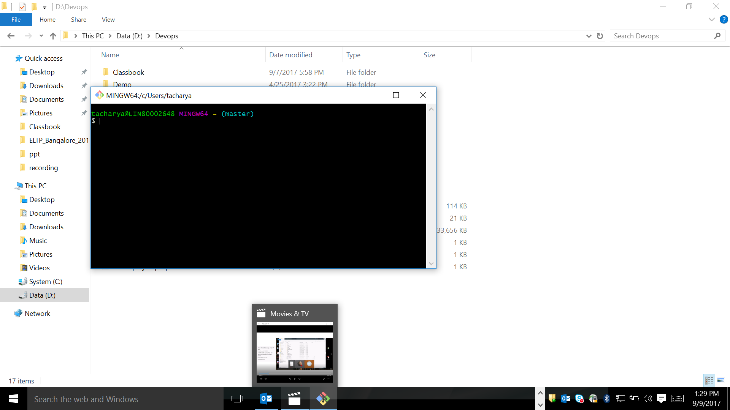

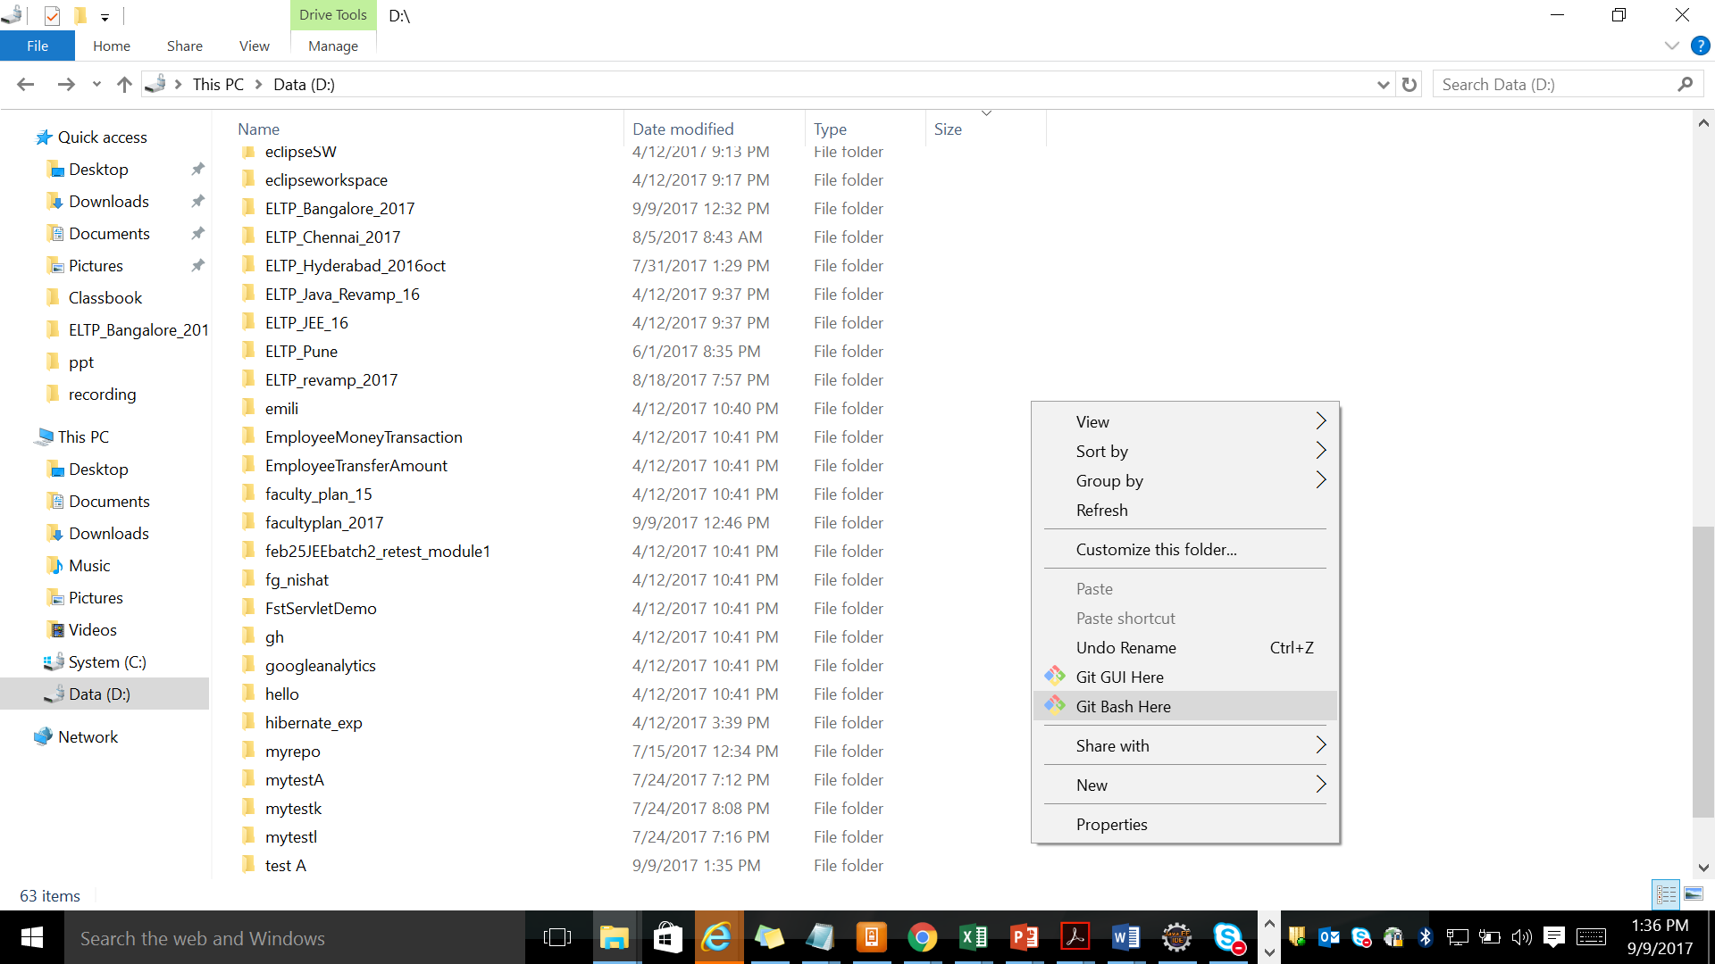

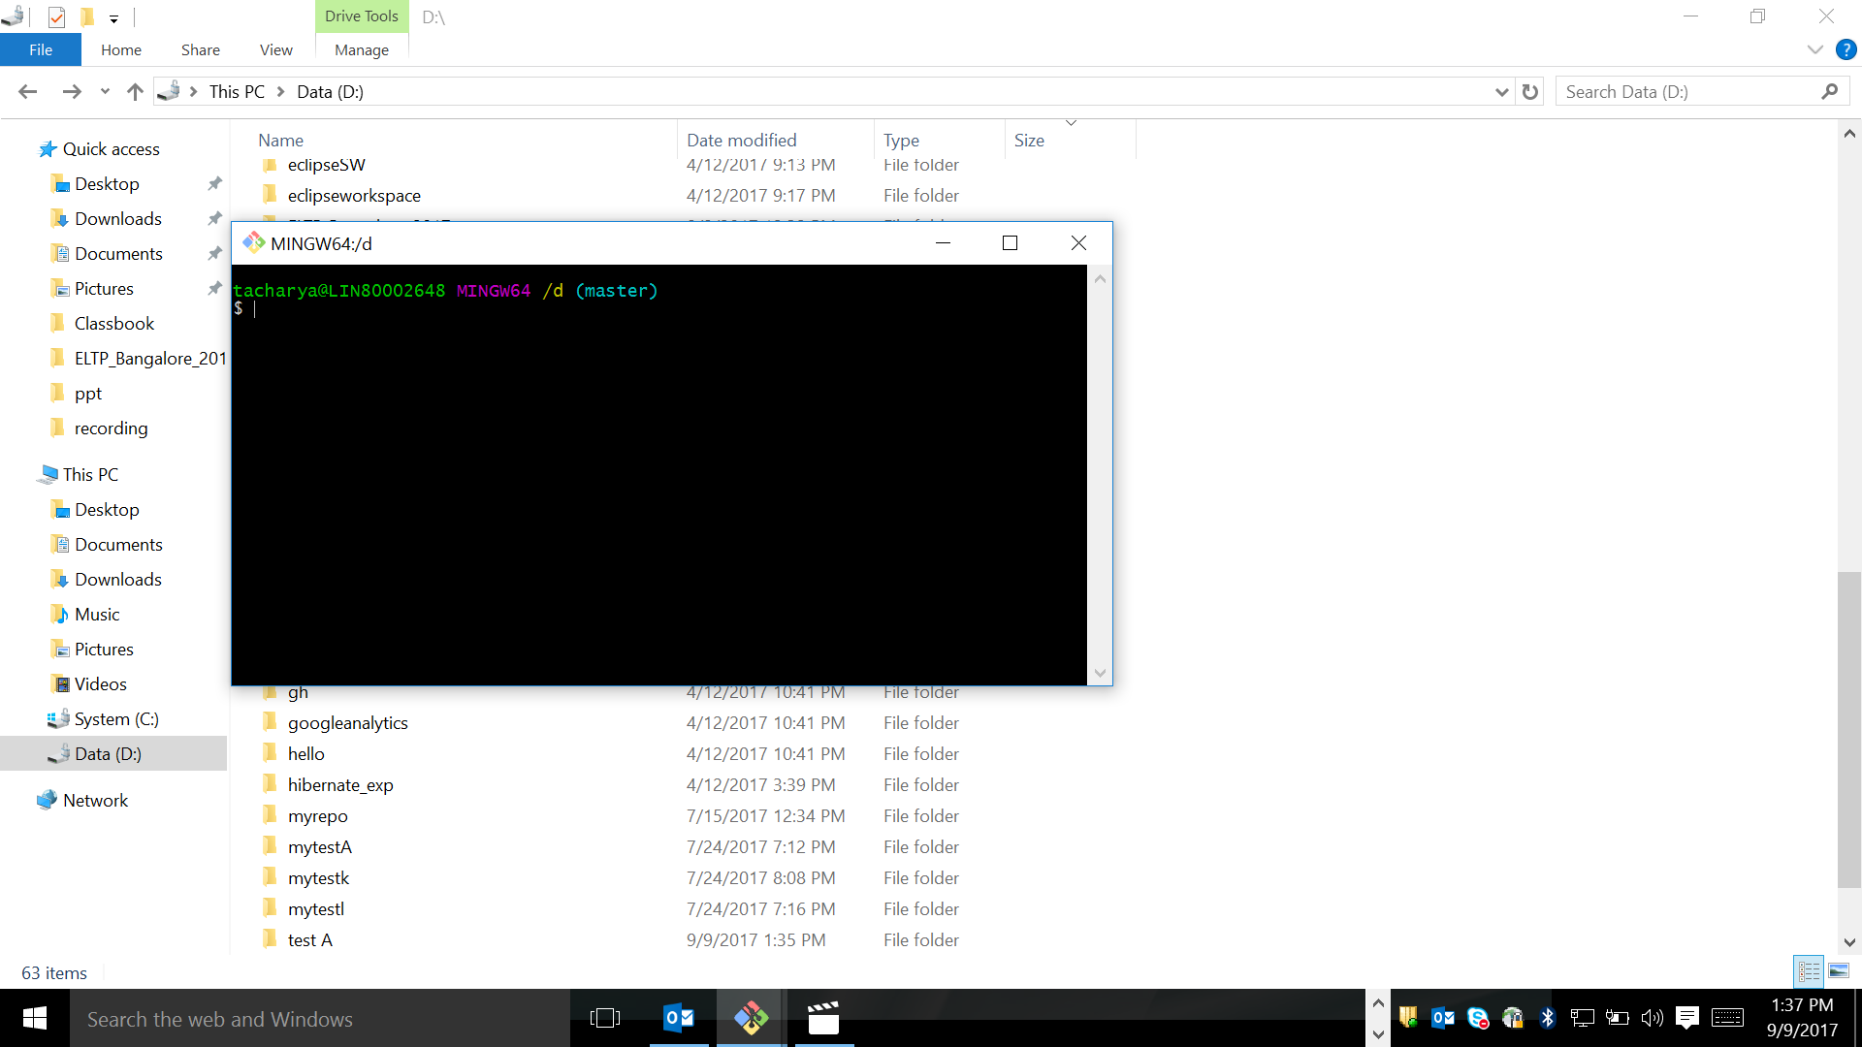

To create a local reposotery mytestA in D:\

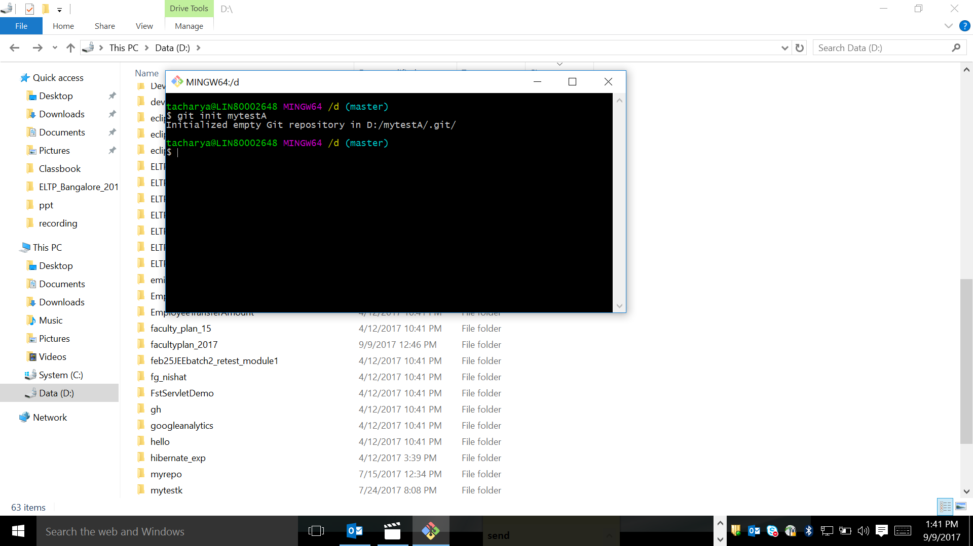

Please check the repootery

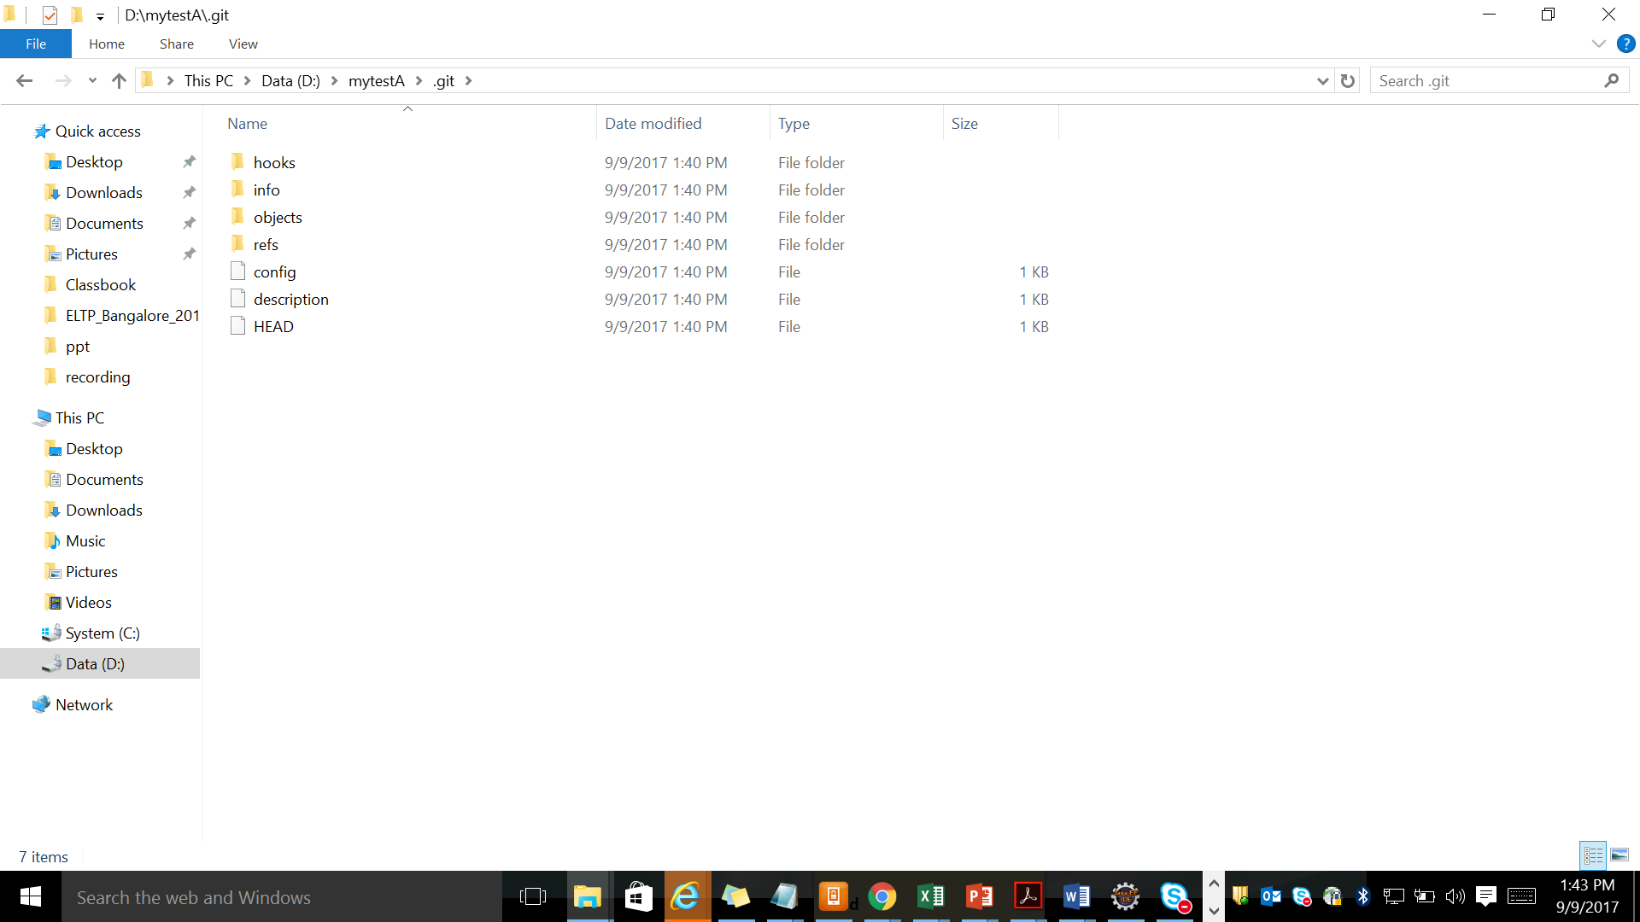

Once more repository created myTtestB in D:\

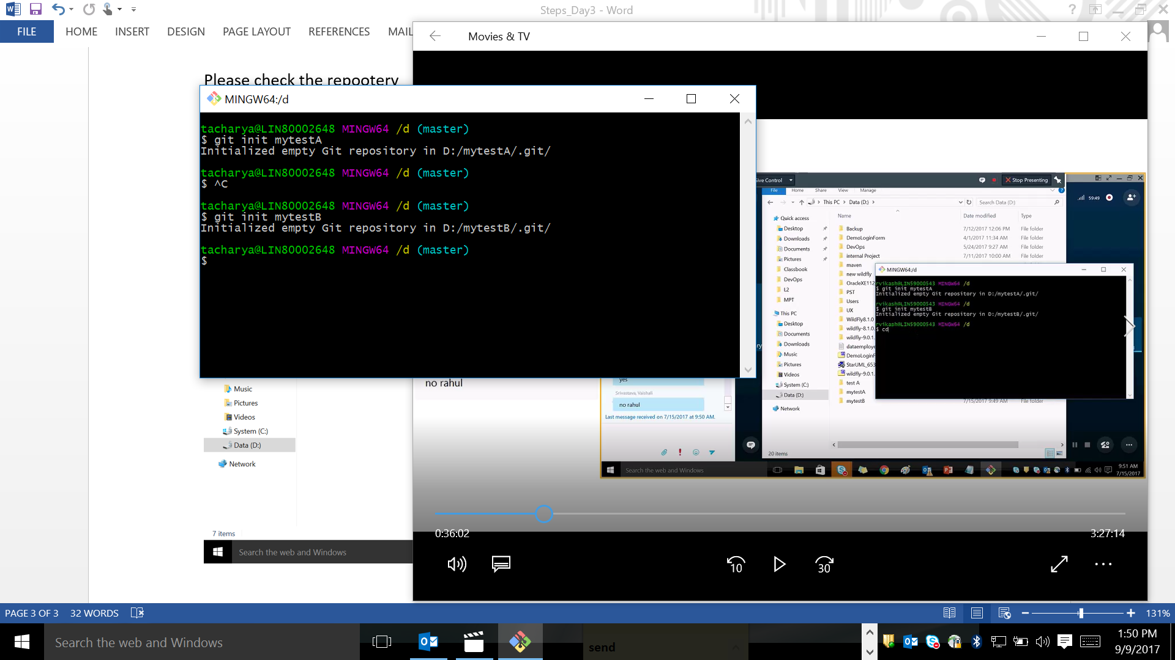

Please create a text file in mytestA and go to mytestA folder by using “cd” command and use “ls” command to see the content of mytestA.

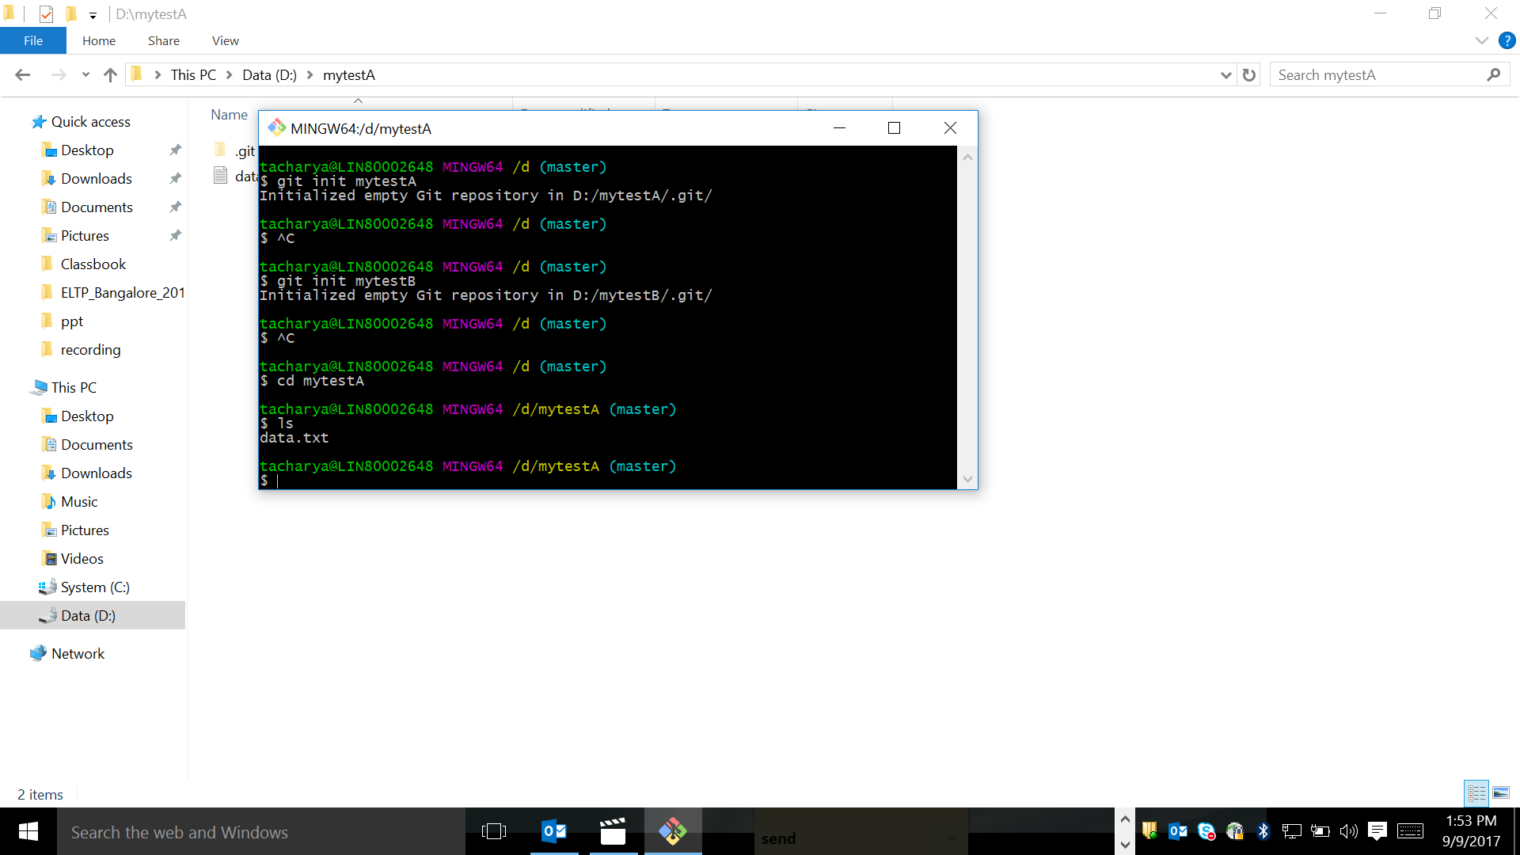

Type something in data.txt file

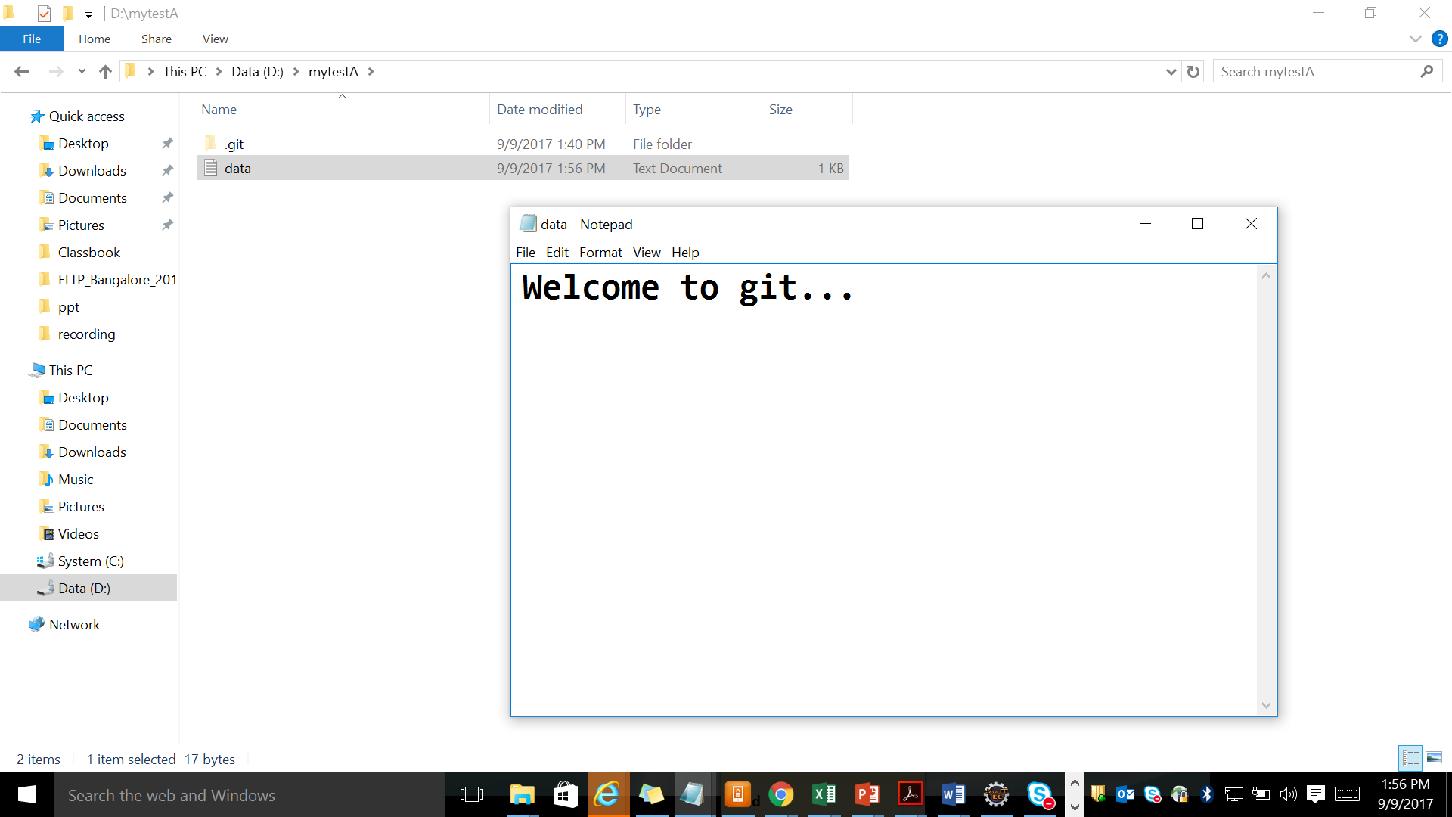

Now add data.txt file to staging area . PFB the commands

git add data.txt

git add . // will add all files to staging area

Any one can be used

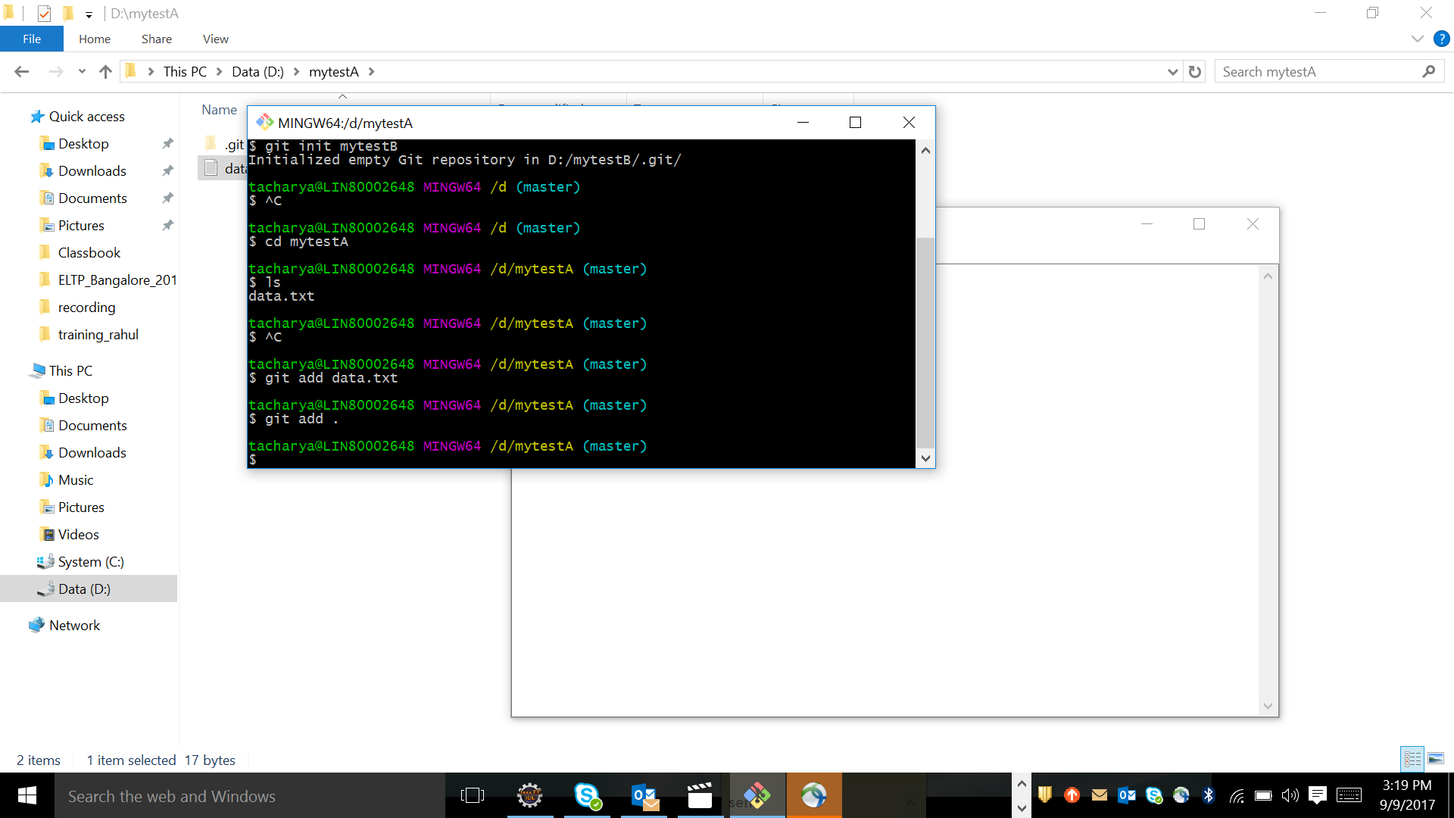

Git status command is used to know in which branch the user are . He is in master

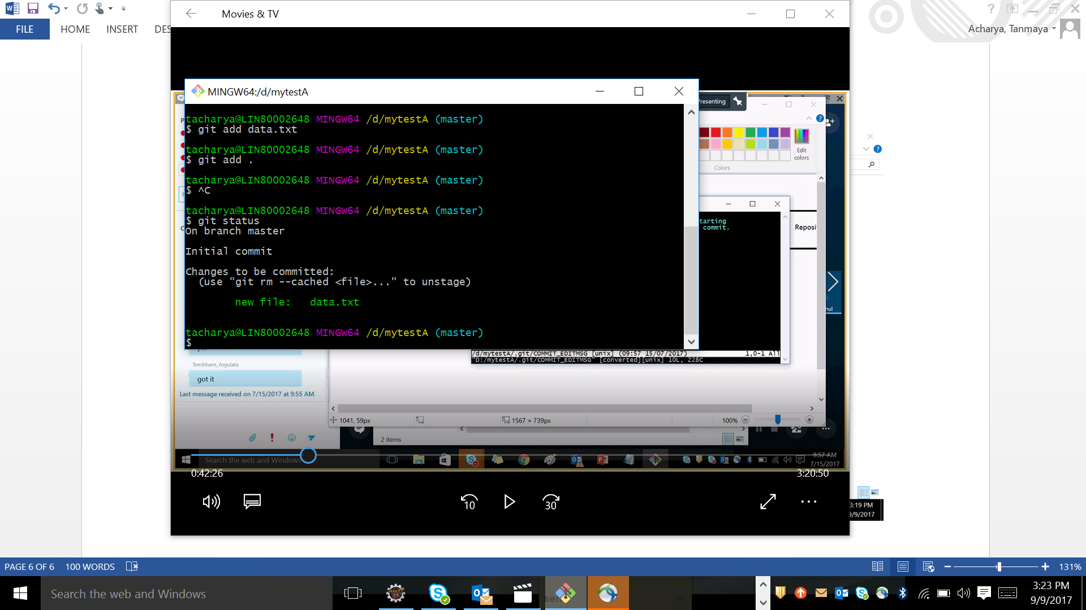

To add from staging area to LR below commands are used

1. Git commit
2. Git commit –m “Write a message”

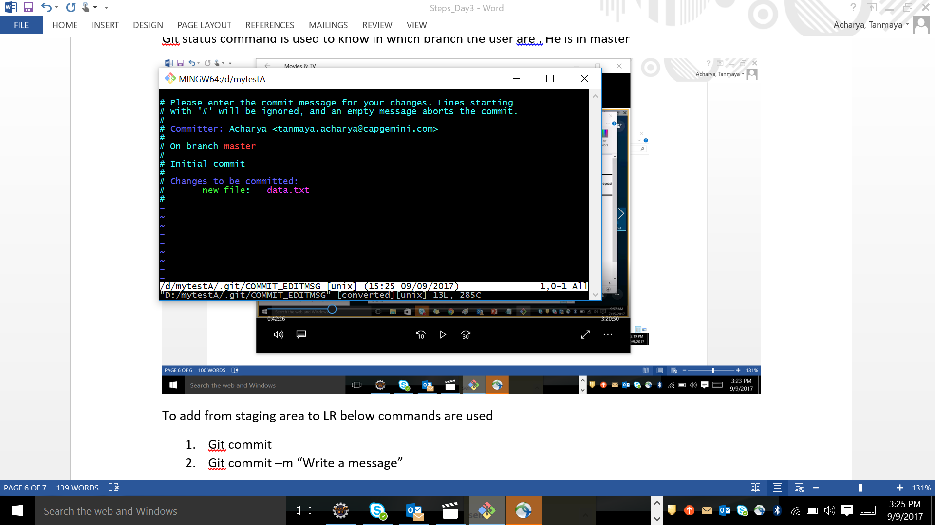

Press insert key and start typing in first line

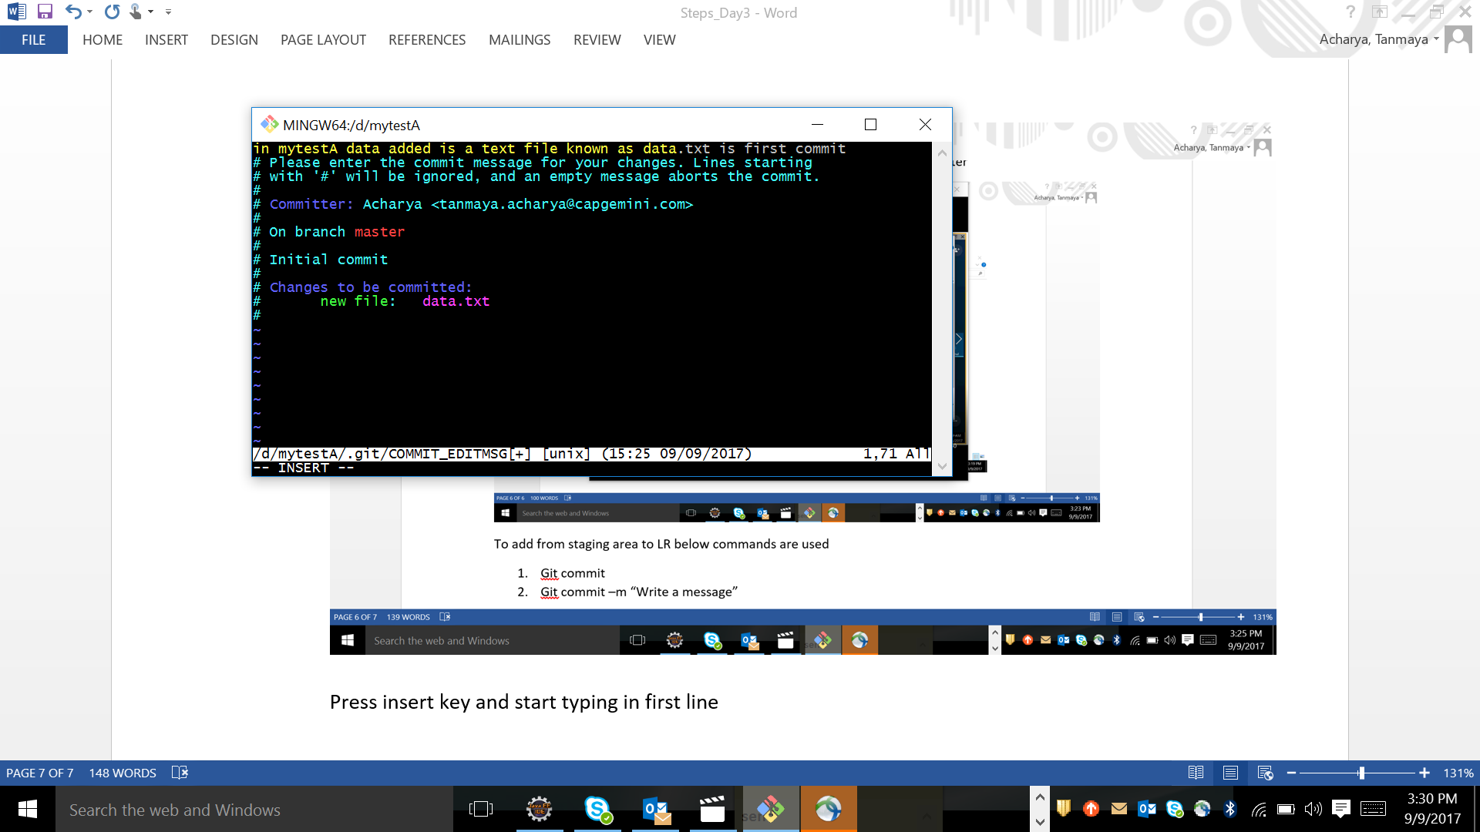

Press Escape key and then :wq <enter> type and come out from this.

Type git status and see the message , nothing to be commited.

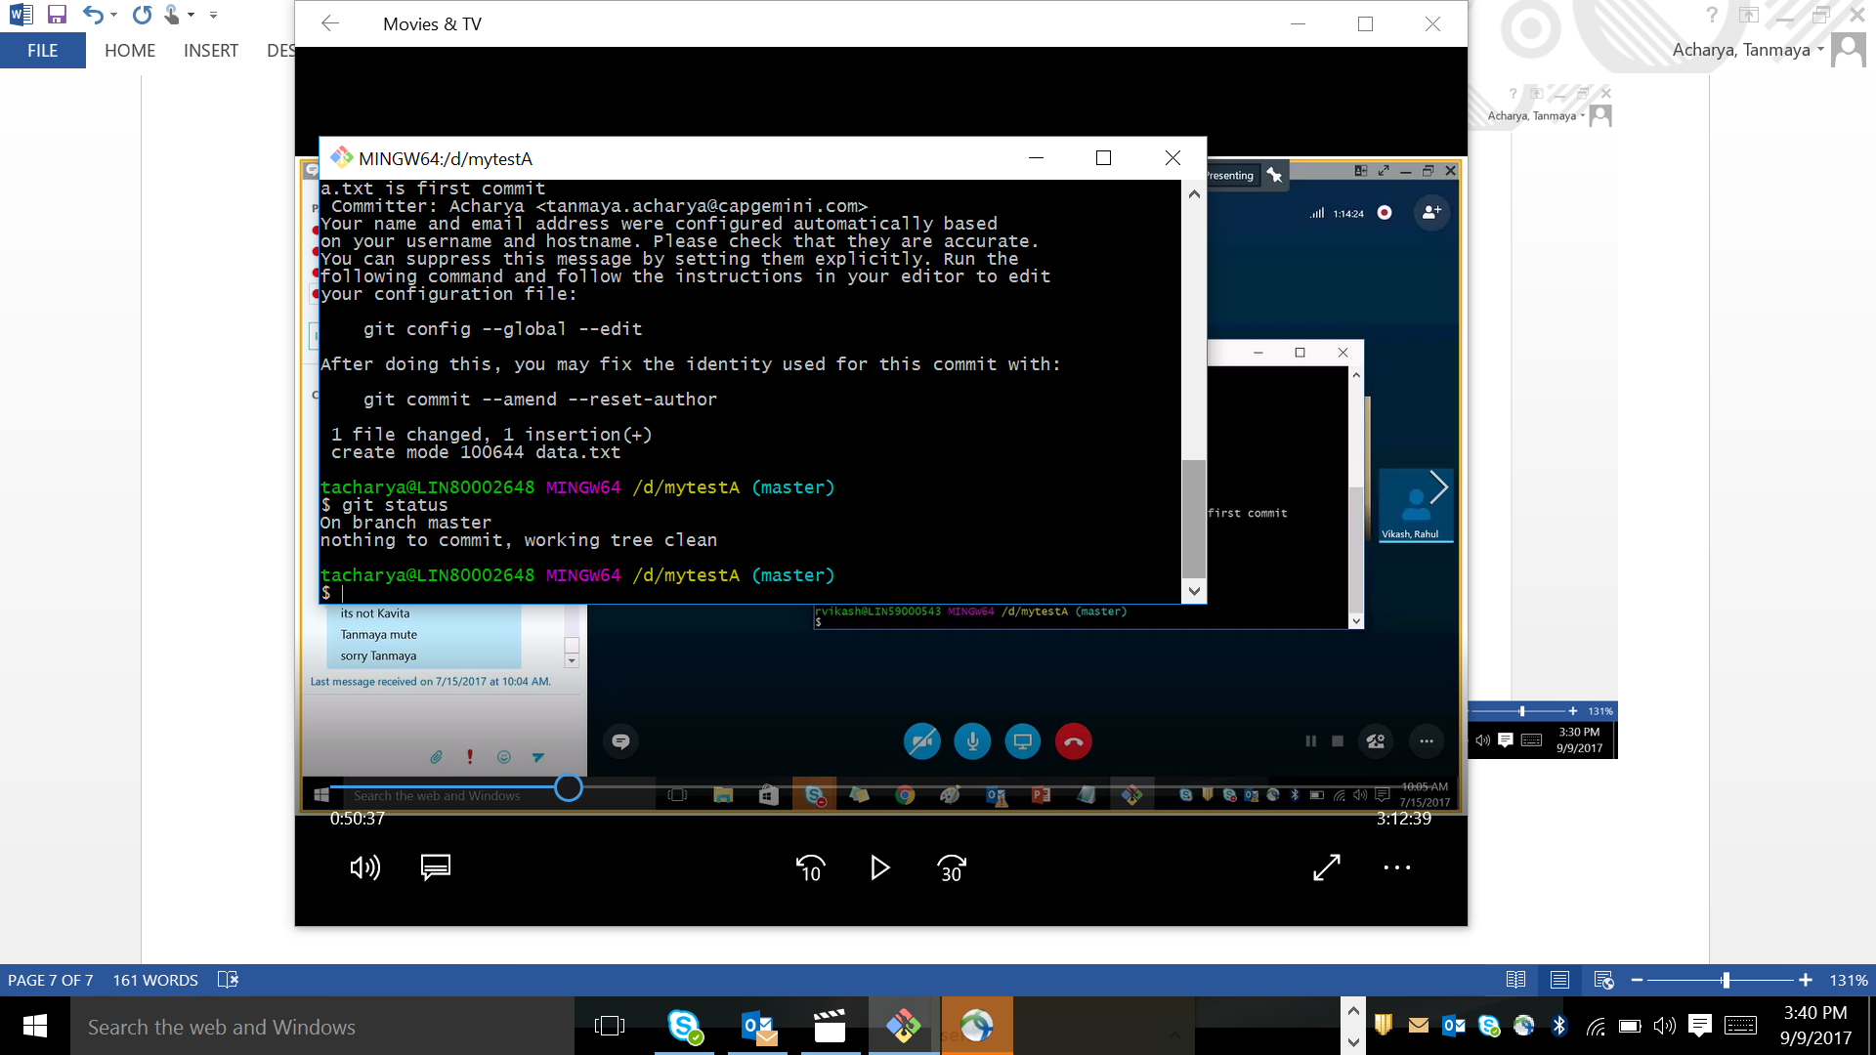

Git log will show the checkson ( 14 digit number )

status given by commit before.

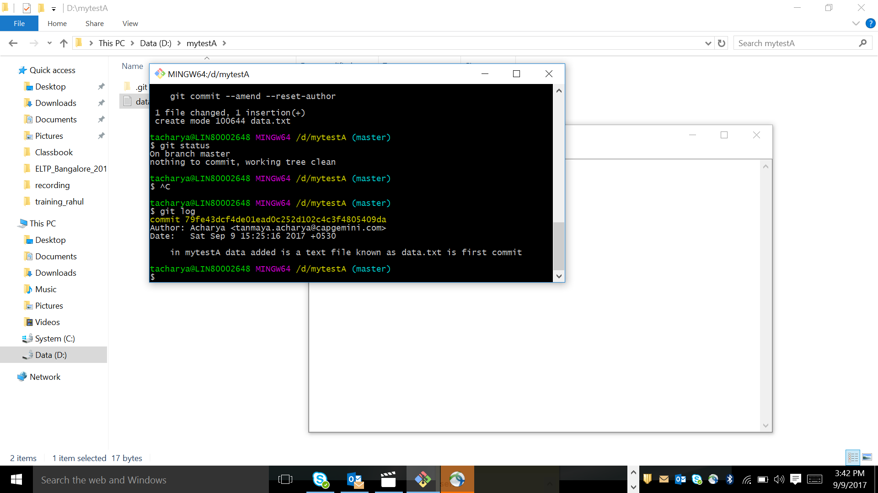

I have created 1 more file abc.txt in mytestA folder and type the data in file and save.

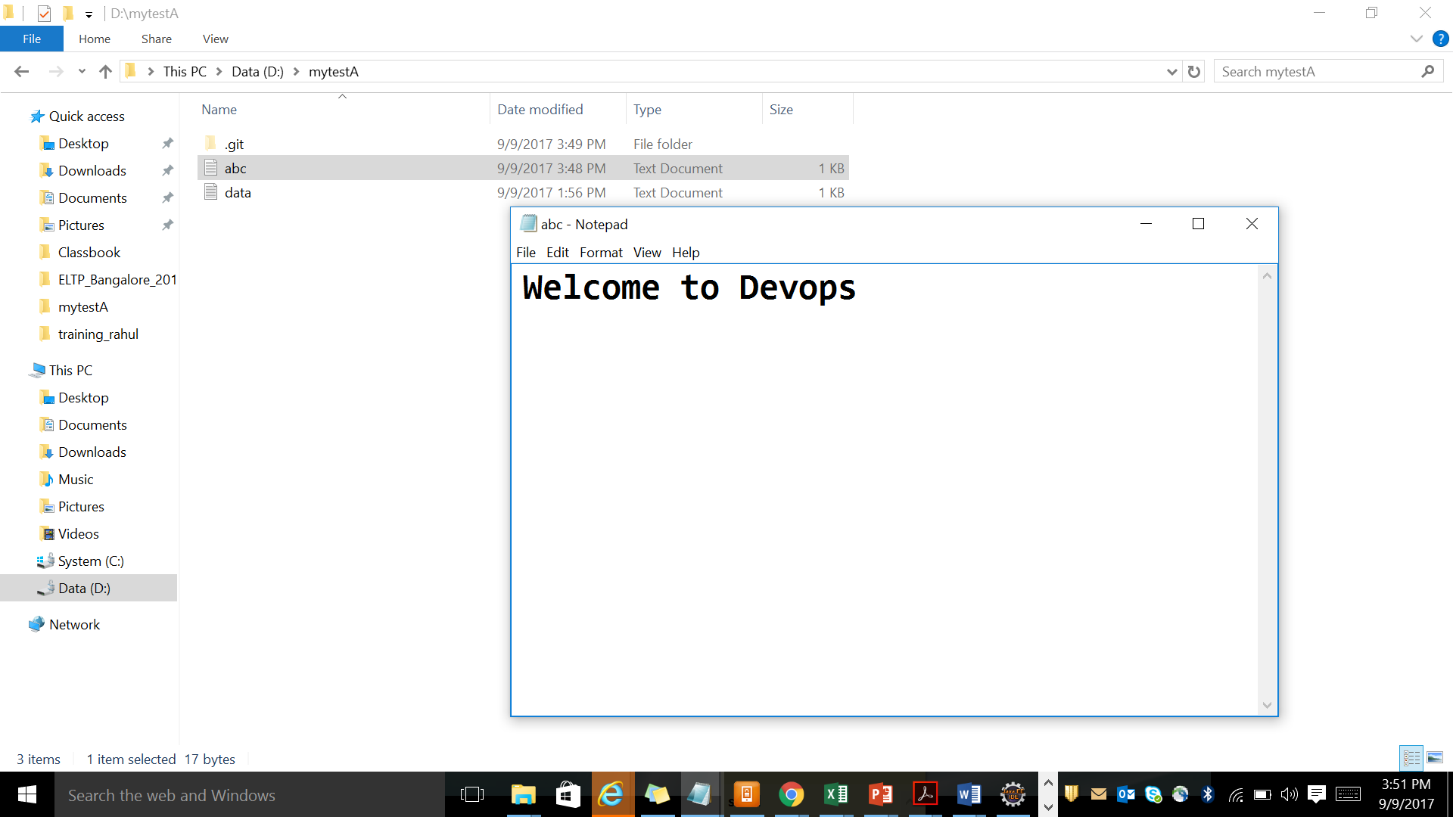

After that check the command ls , git status

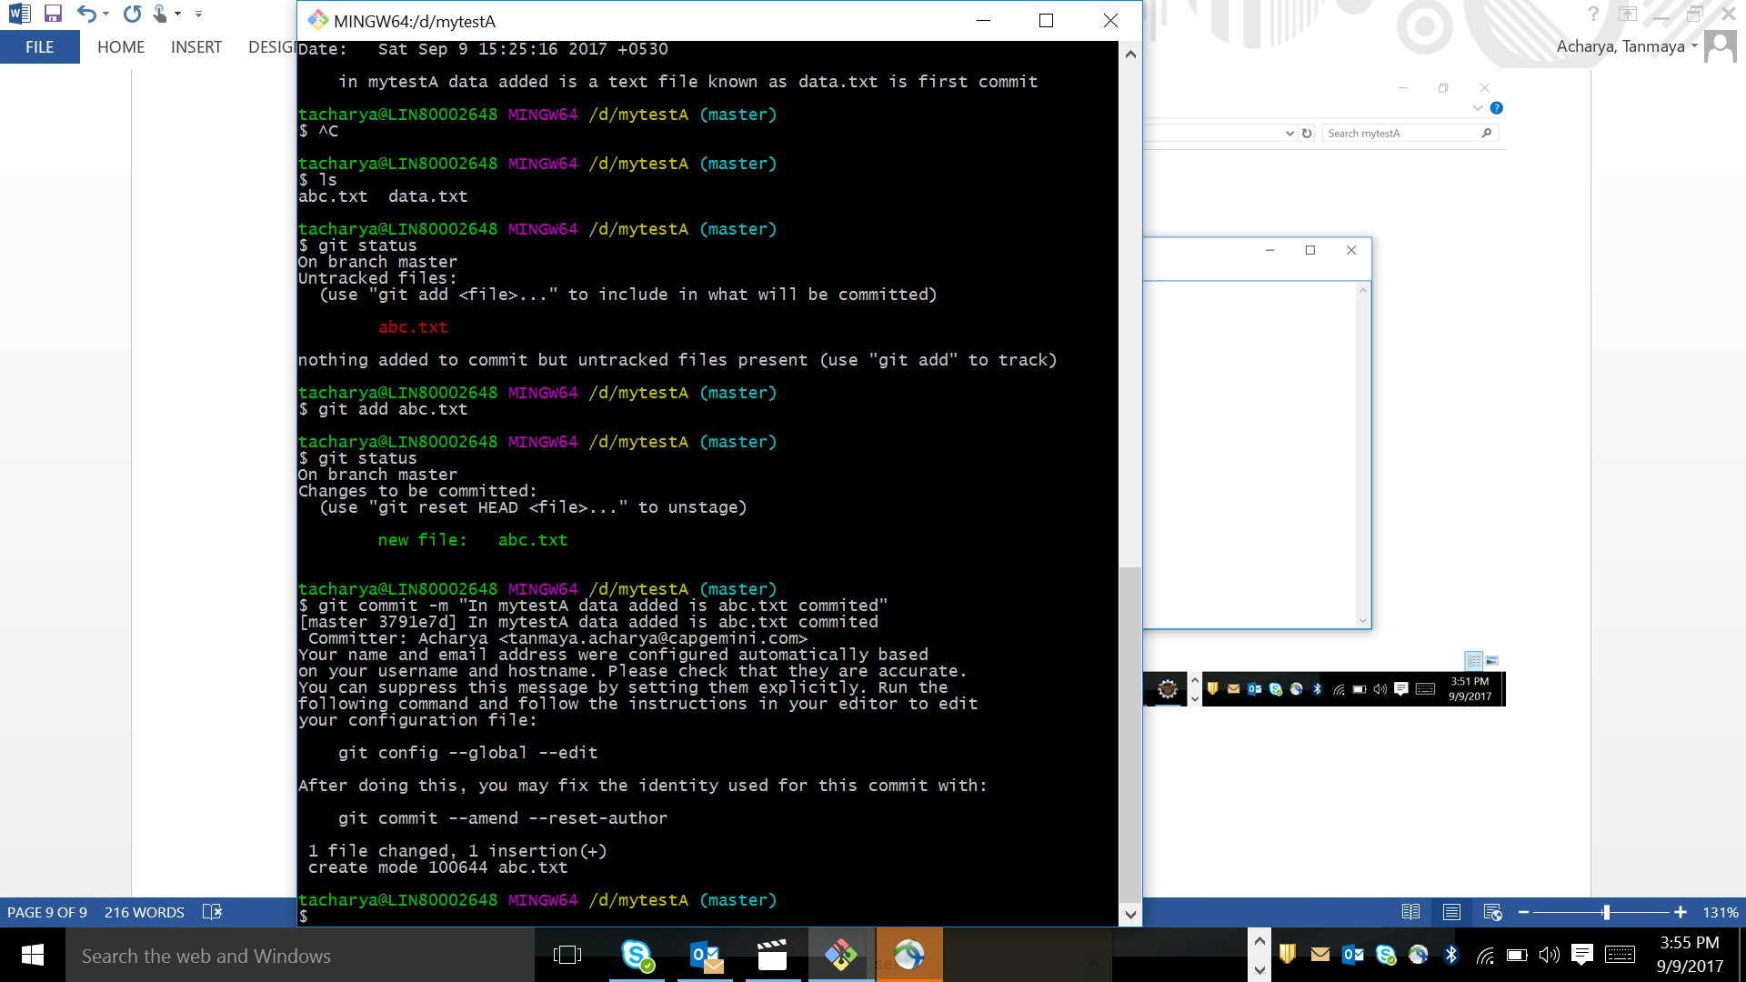

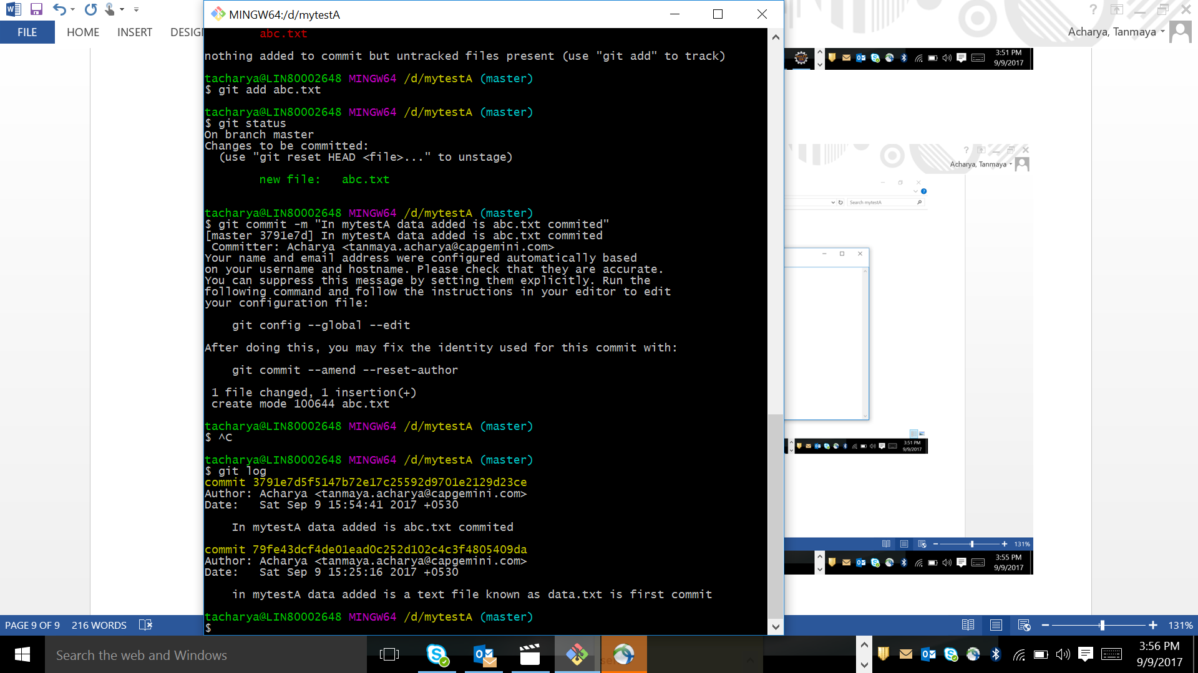

Check the branch and create a new branch . current branch will be shown in green color

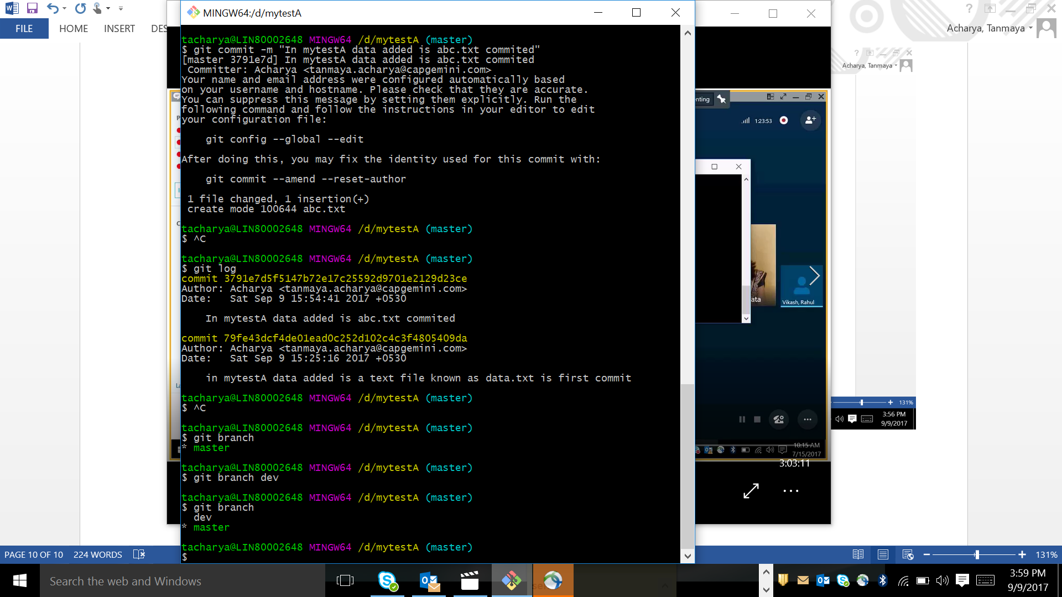

How to switch one branch to another

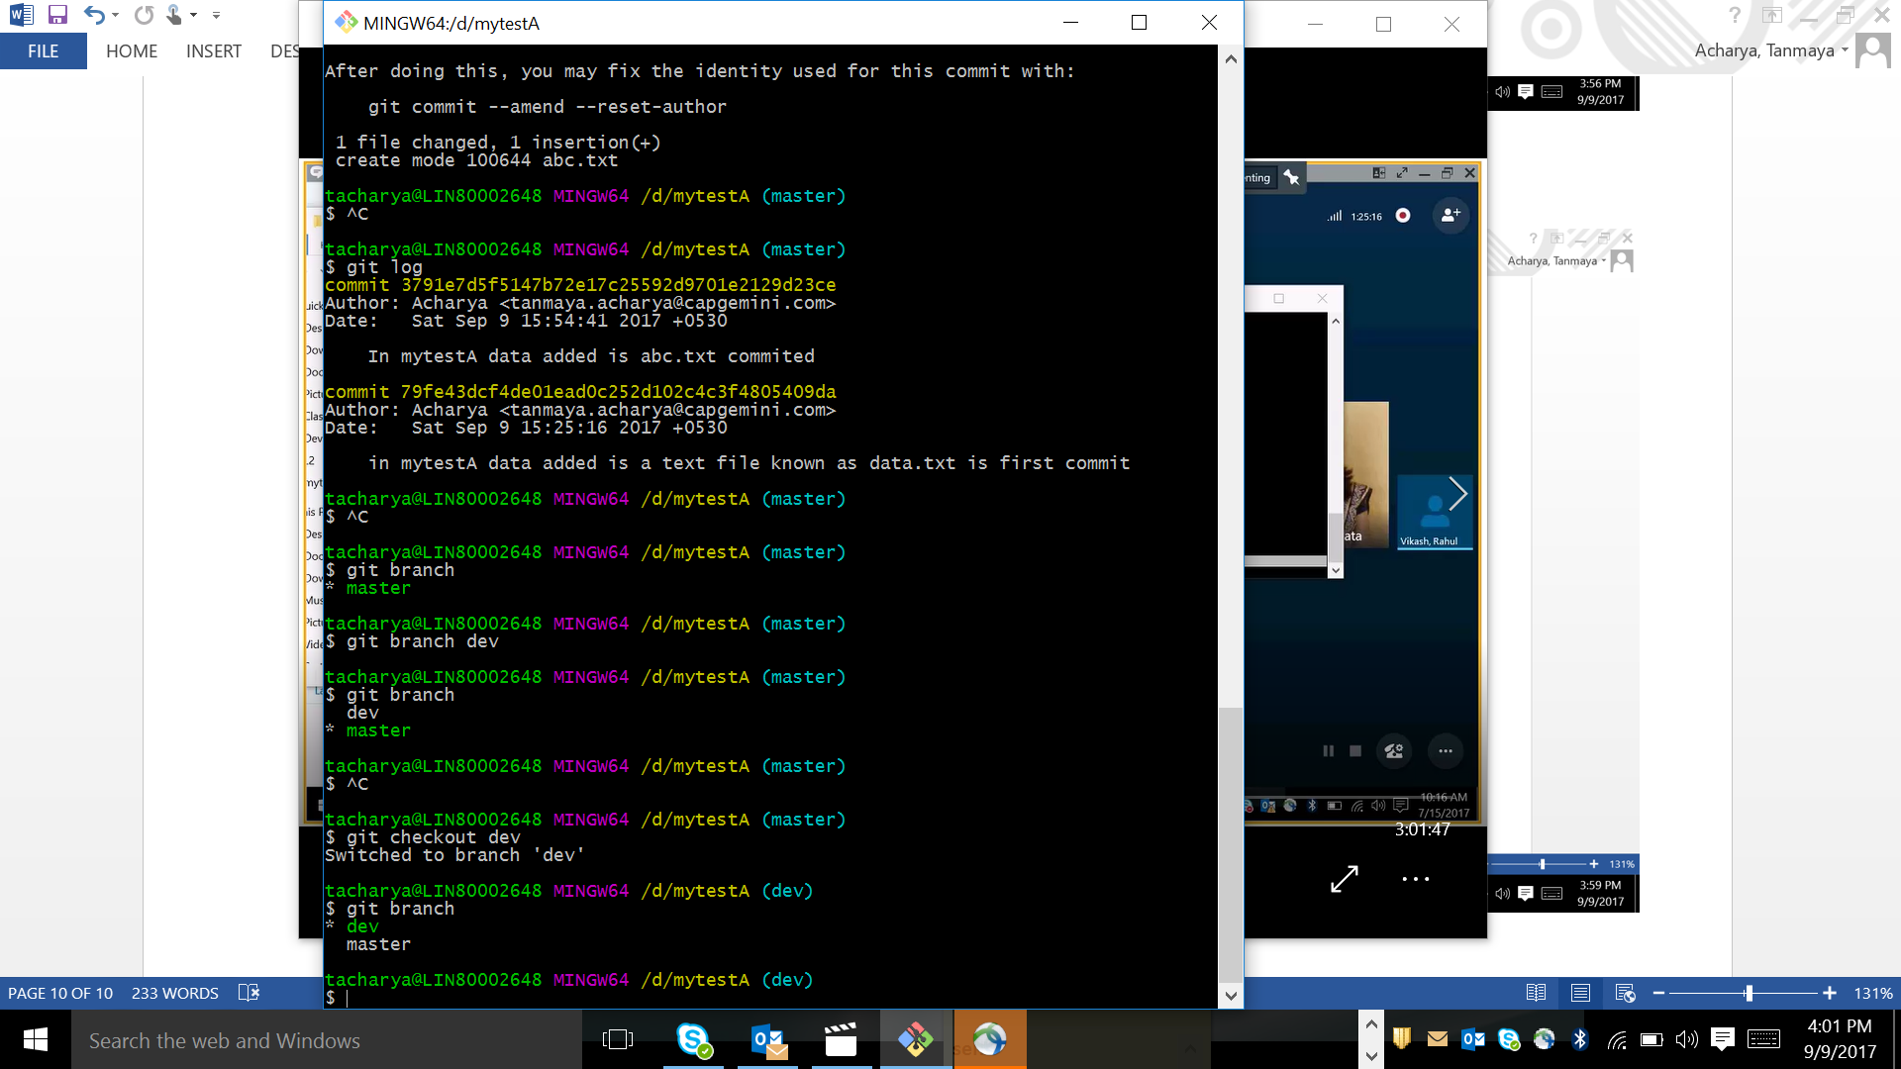

We can see in our mytestA folder , no change in abc and data file

Now we can add new text to both files.

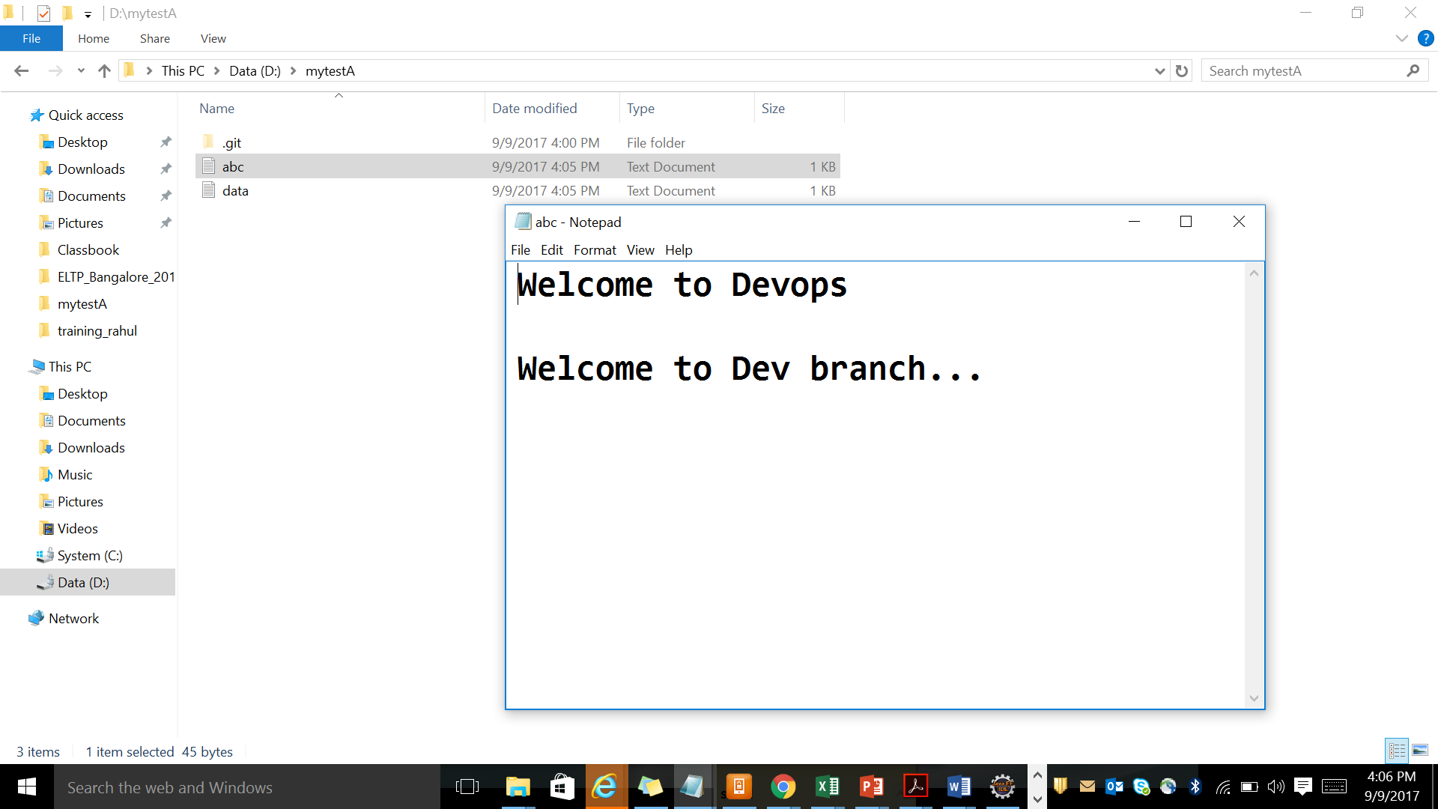

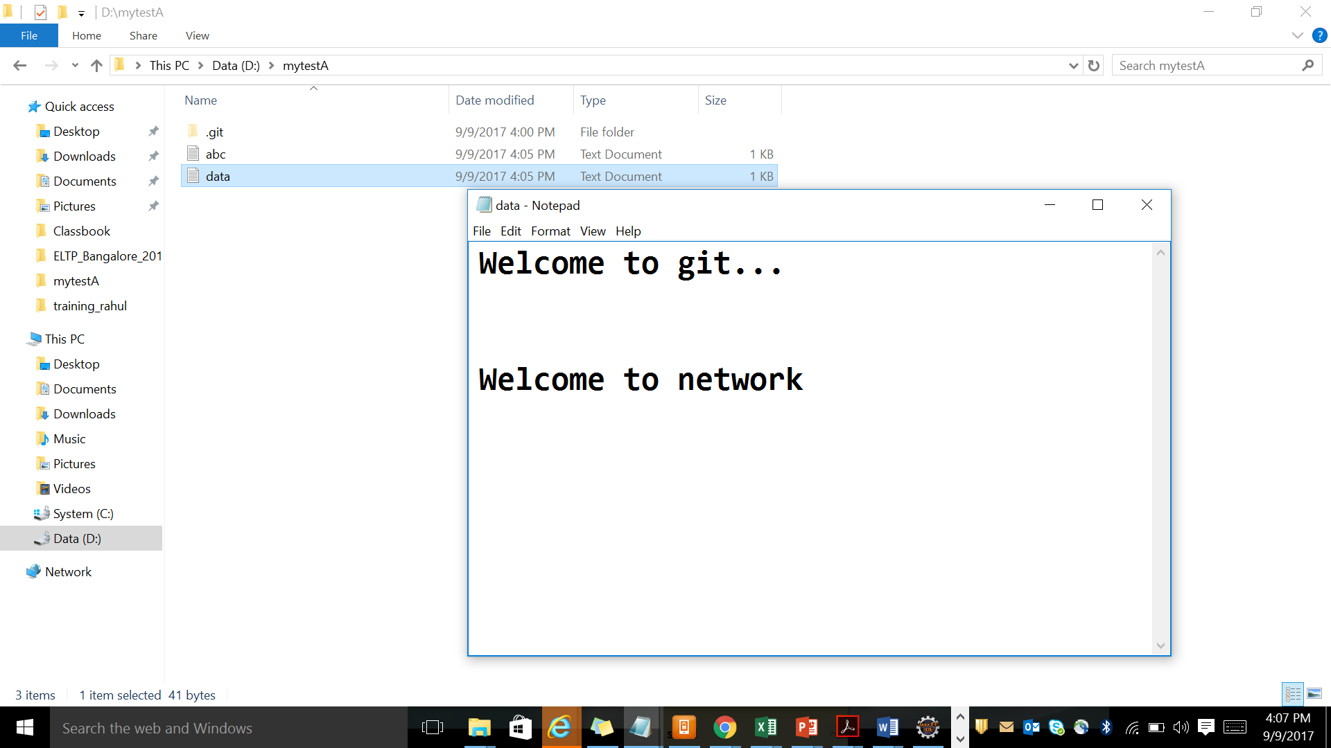

Follow the command to add new data to both files in dev branch

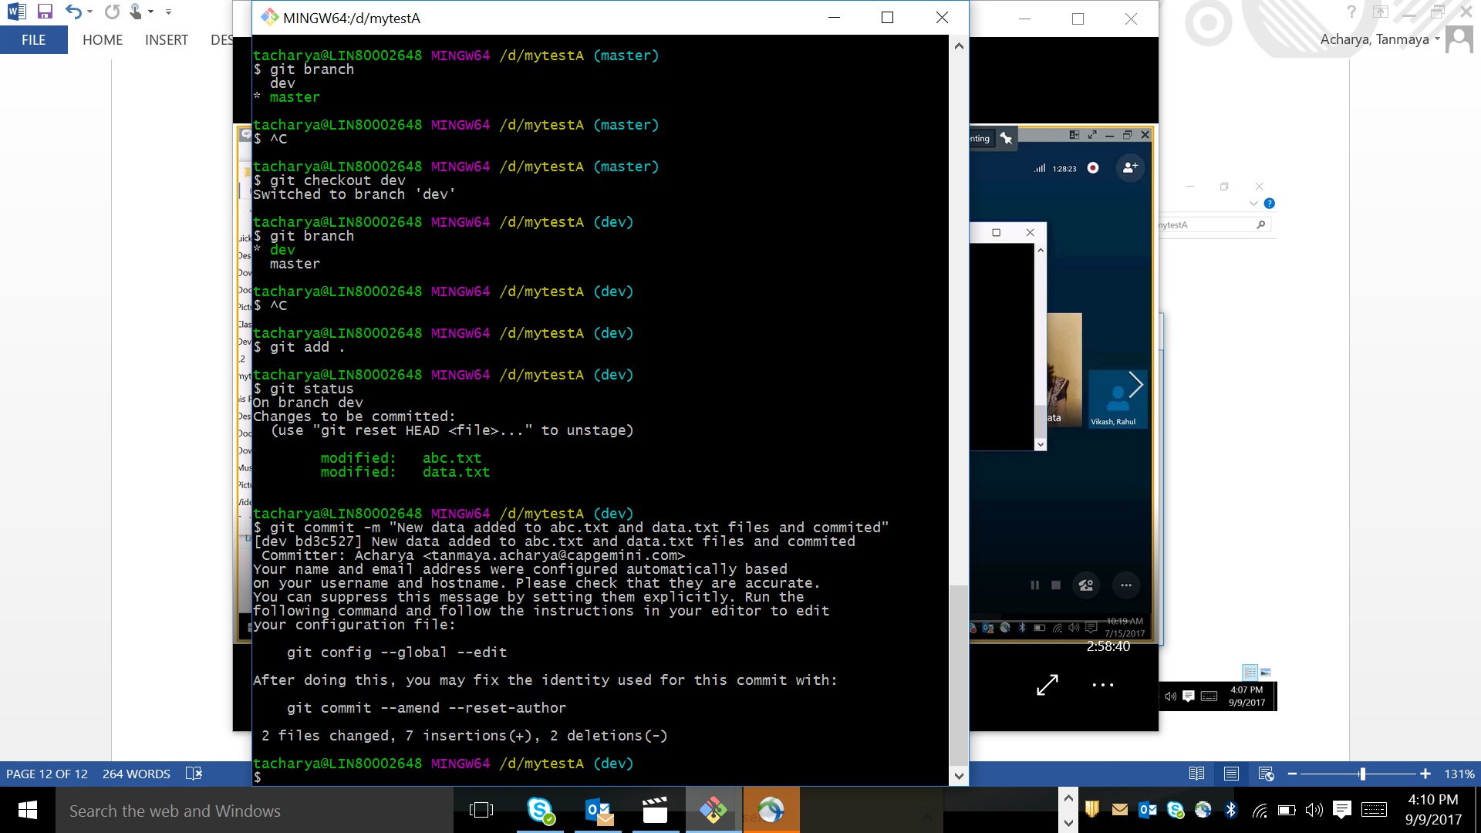

Git add will add the data to staging area and commit will save data from staging area to LR

After switch to Master branch check the content of both files

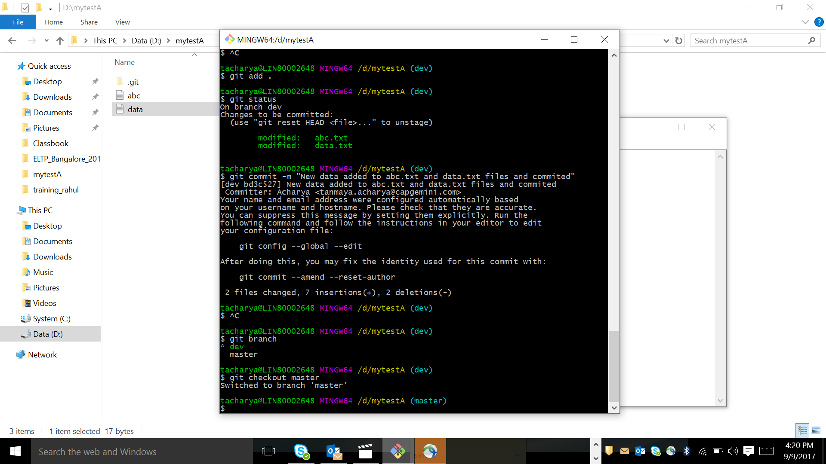

New data added will be not shown to master

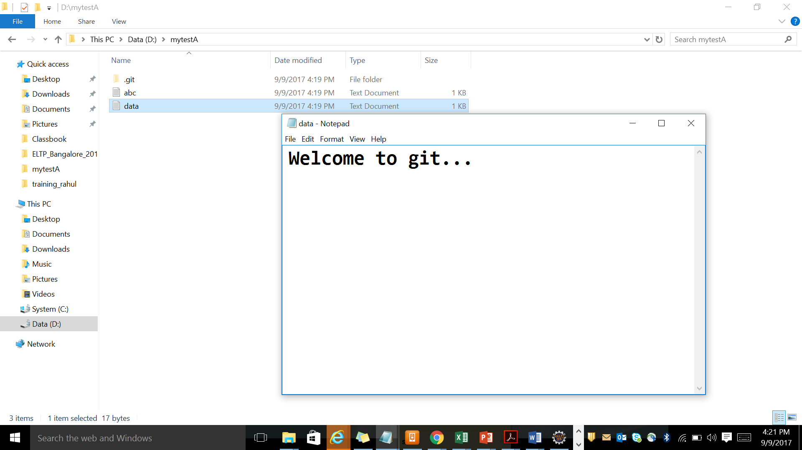

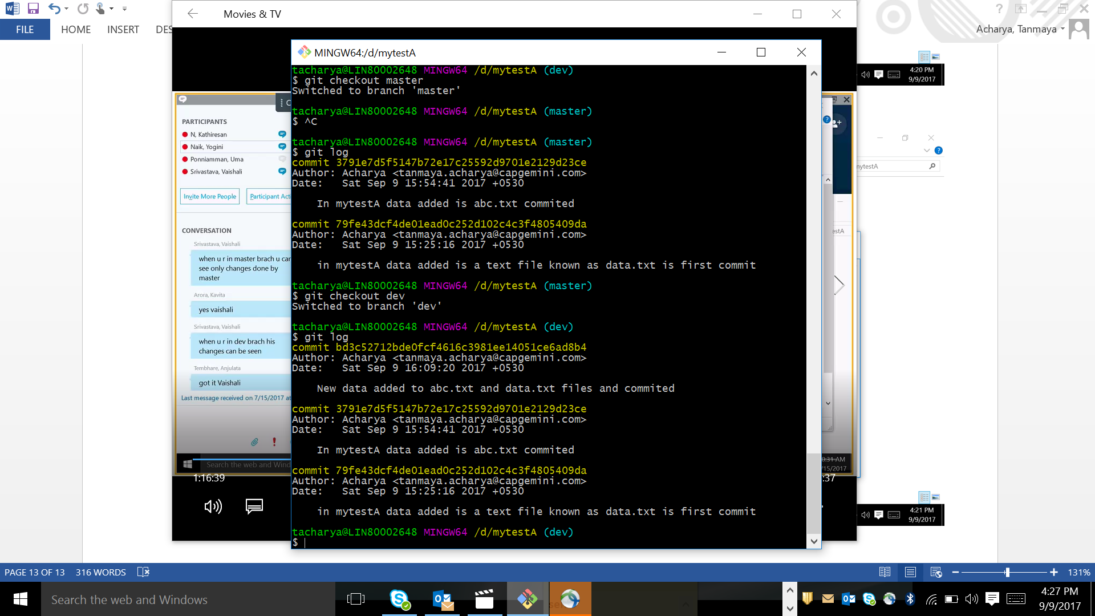

This is how distributed version control works. Check once with cat command

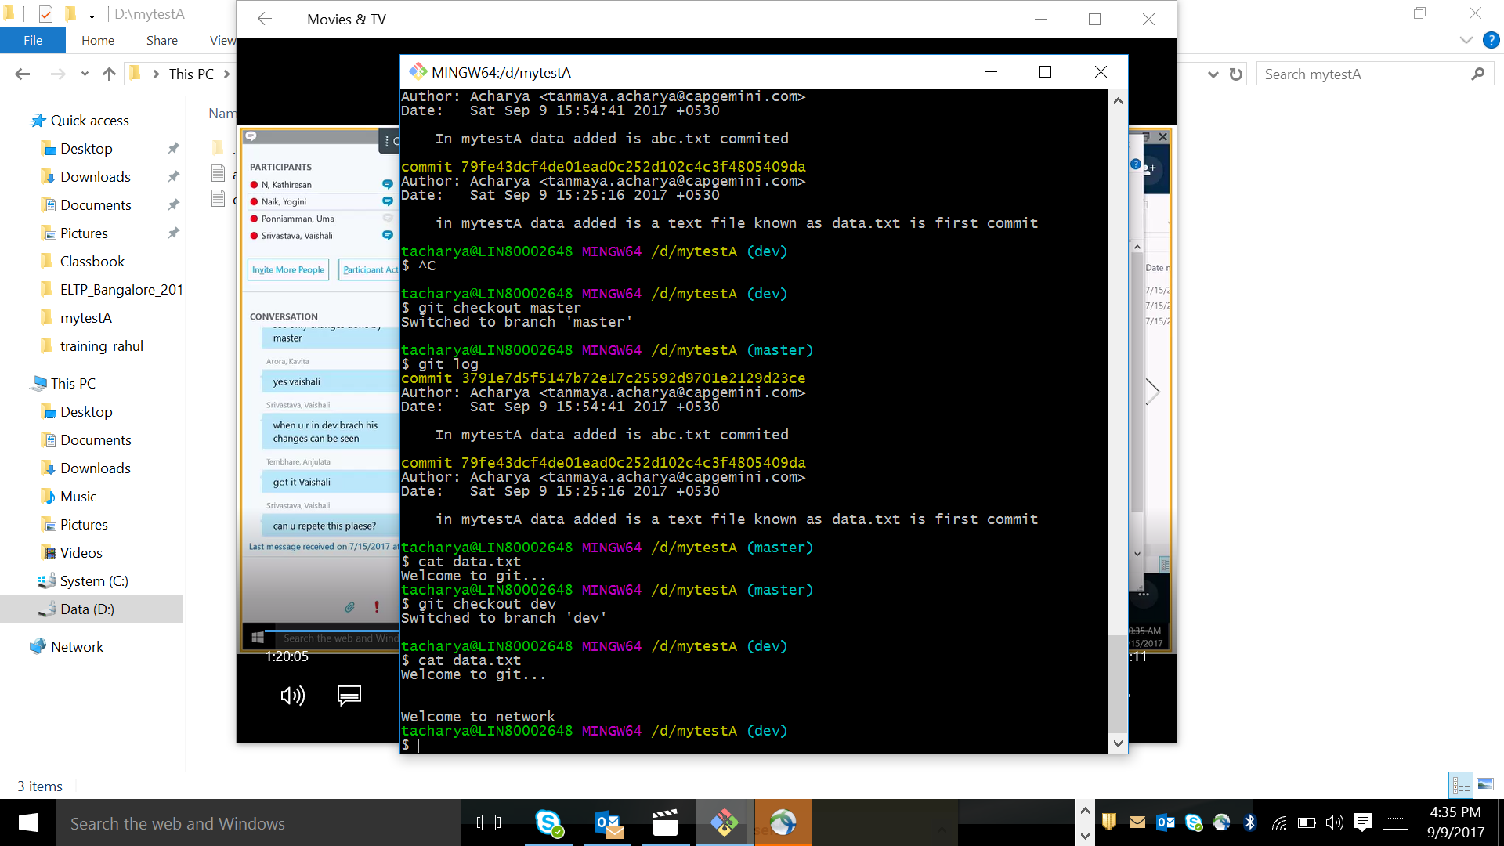

As per the checkout to the branch git checksum head to that branch

Now I m at master branch wants to merge to Dev branch

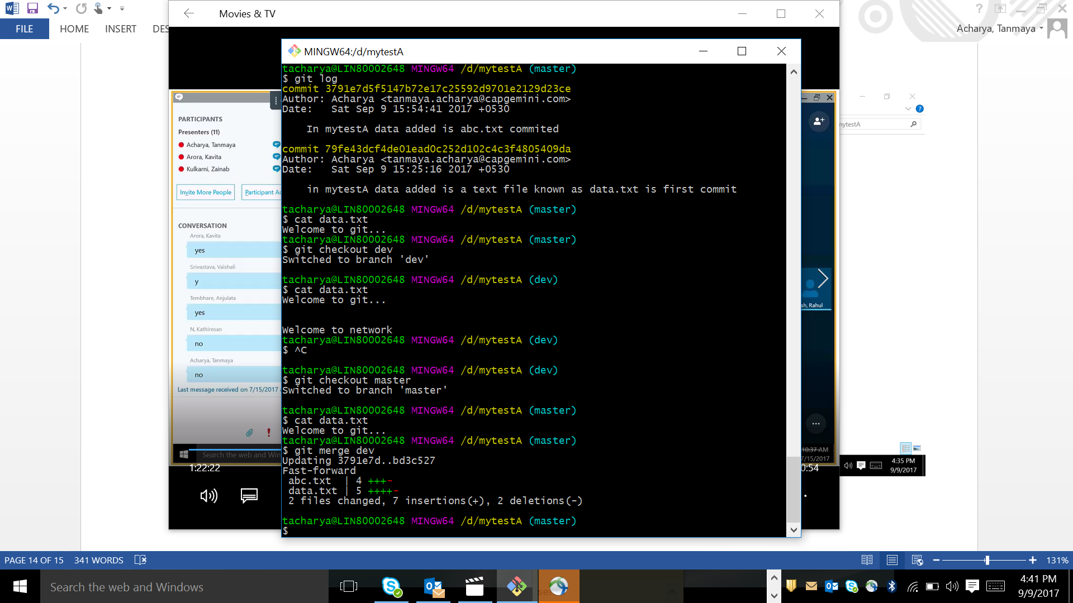

Now see master can get thev merge data

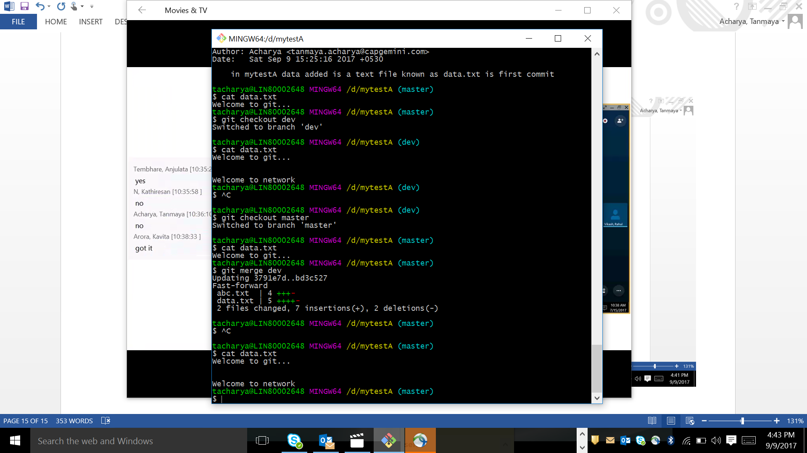

Now in master branch I m adding few more data to abc.txt file.

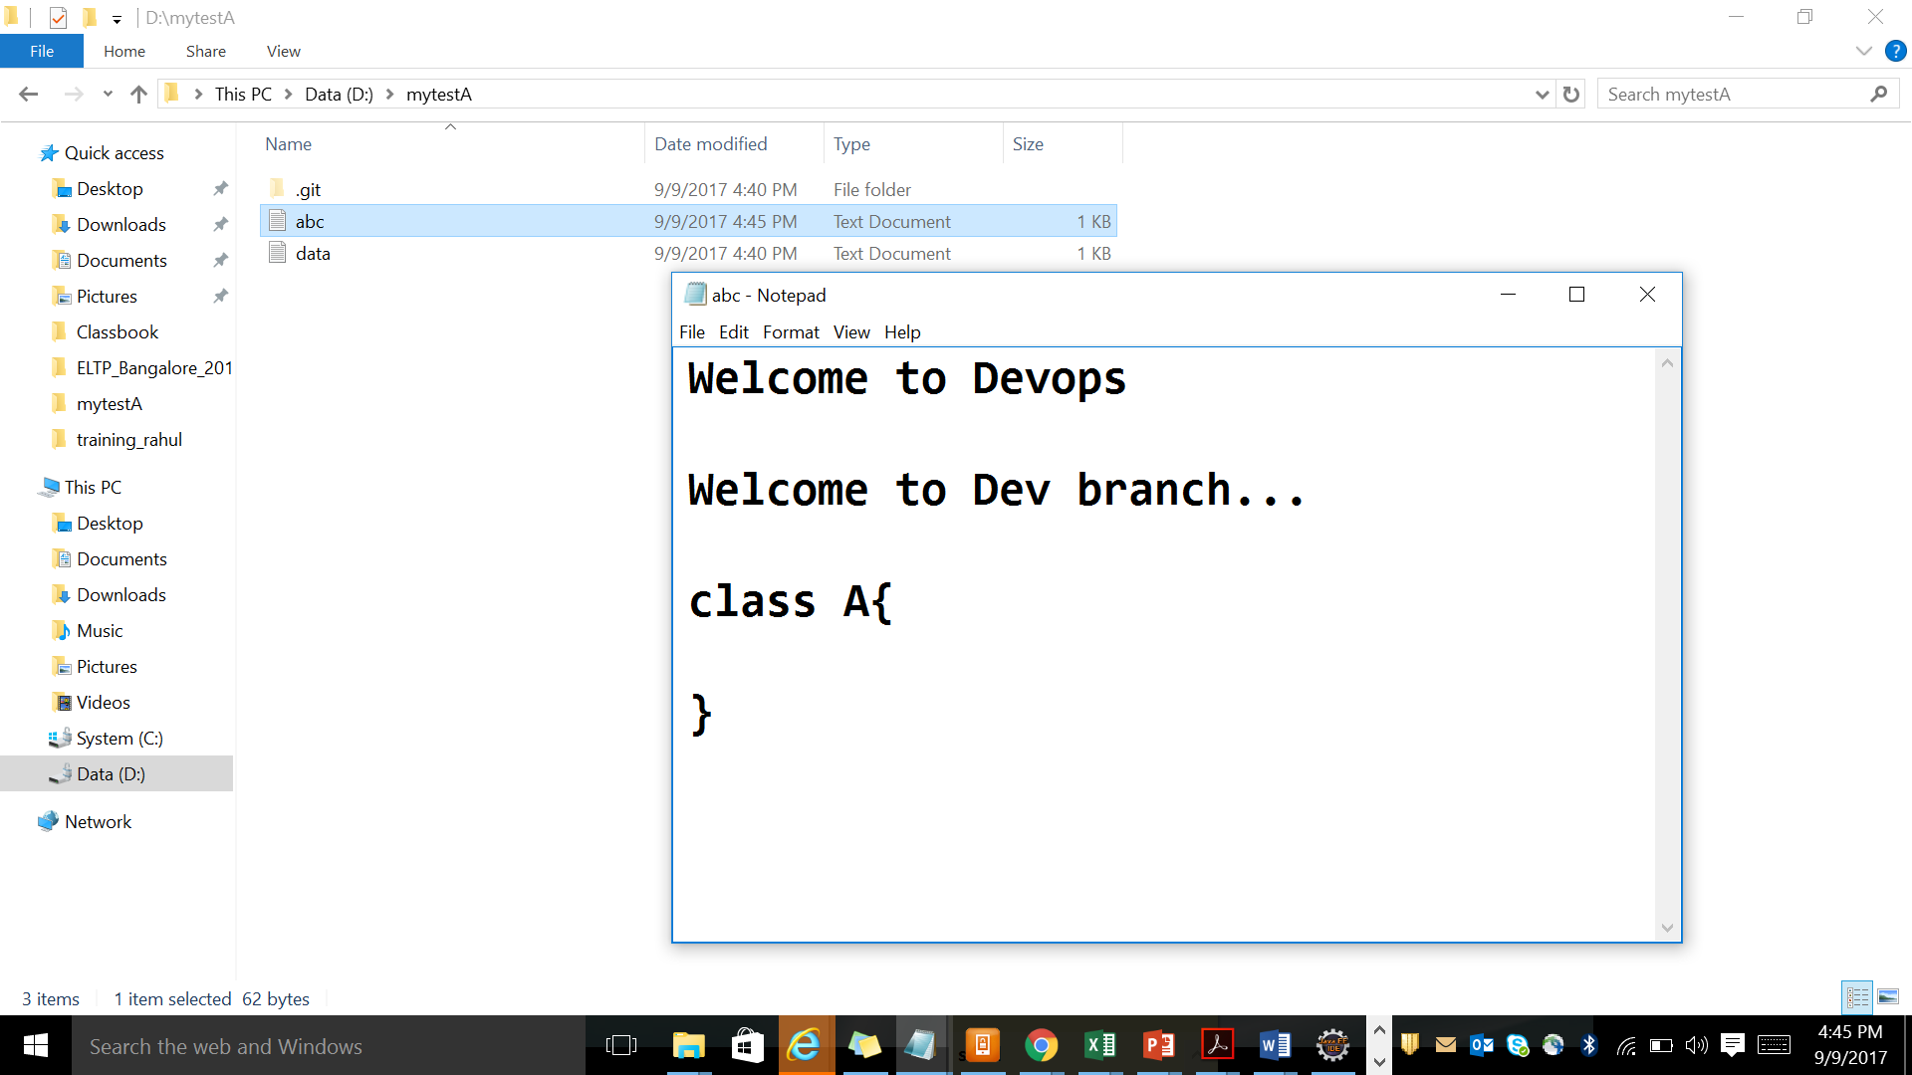

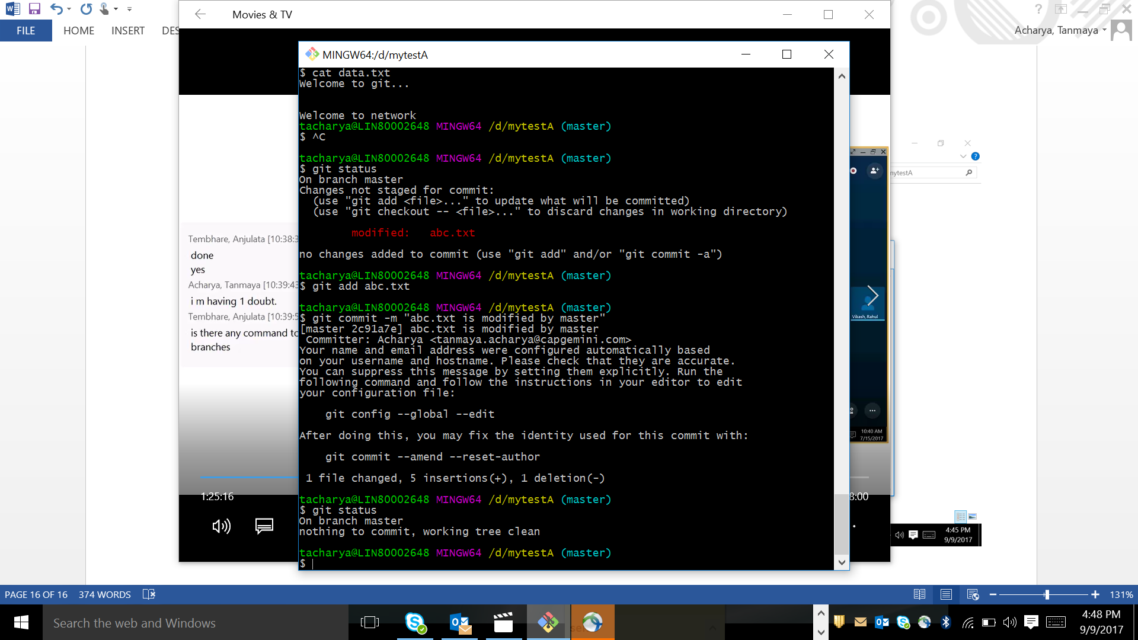

Swiching to dev branch and trying to bserbve the changes and finally merge to master

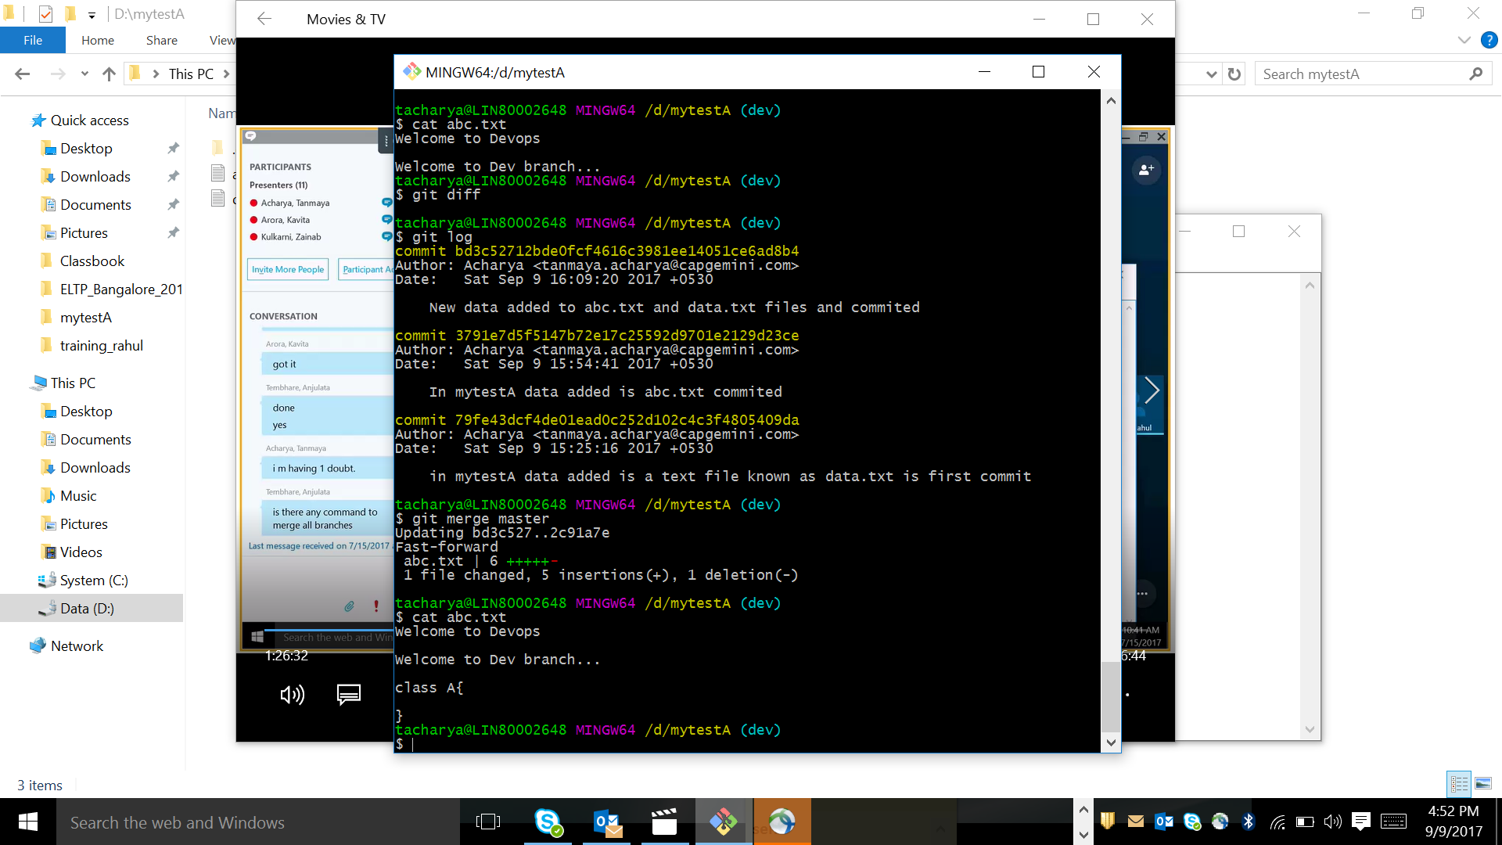

How to create a branch and switch to it . refer in ppt slide 21.

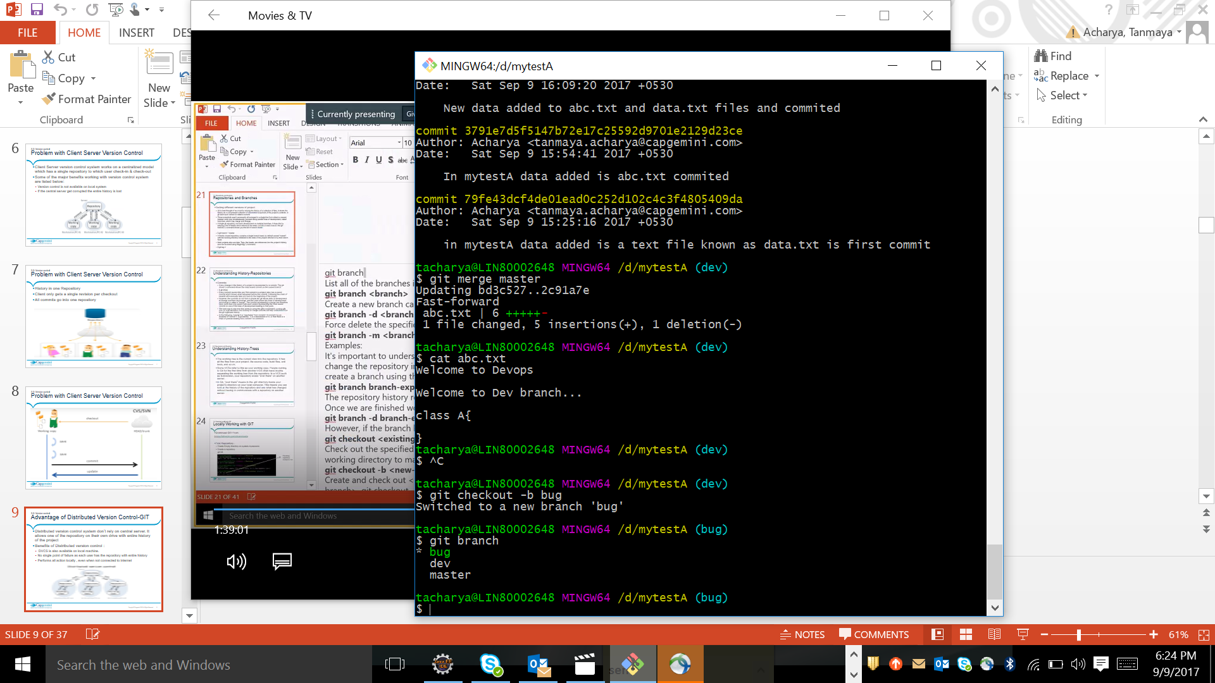

I saw the data of both the text files in mytestA in bug branch.

I am going to delete the below 2 lines of abc.txt file.

Welcome to Devops

Welcome to Dev branch...

Now save abc.txt file and write the command

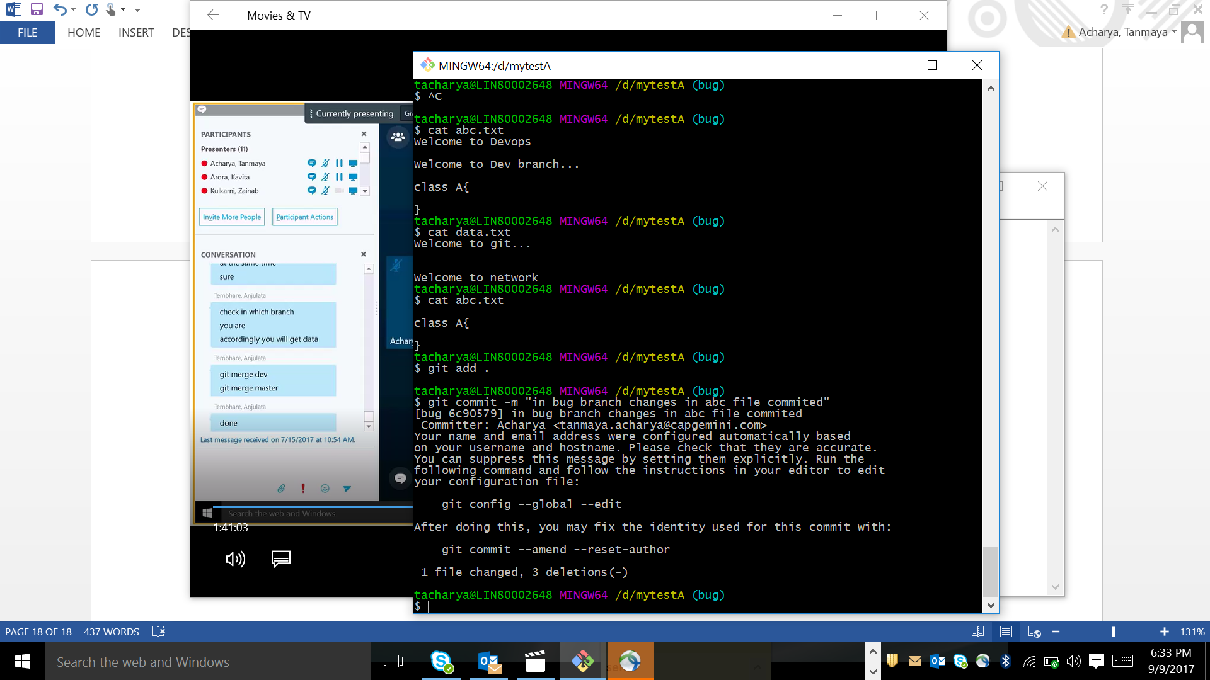

Switching to master

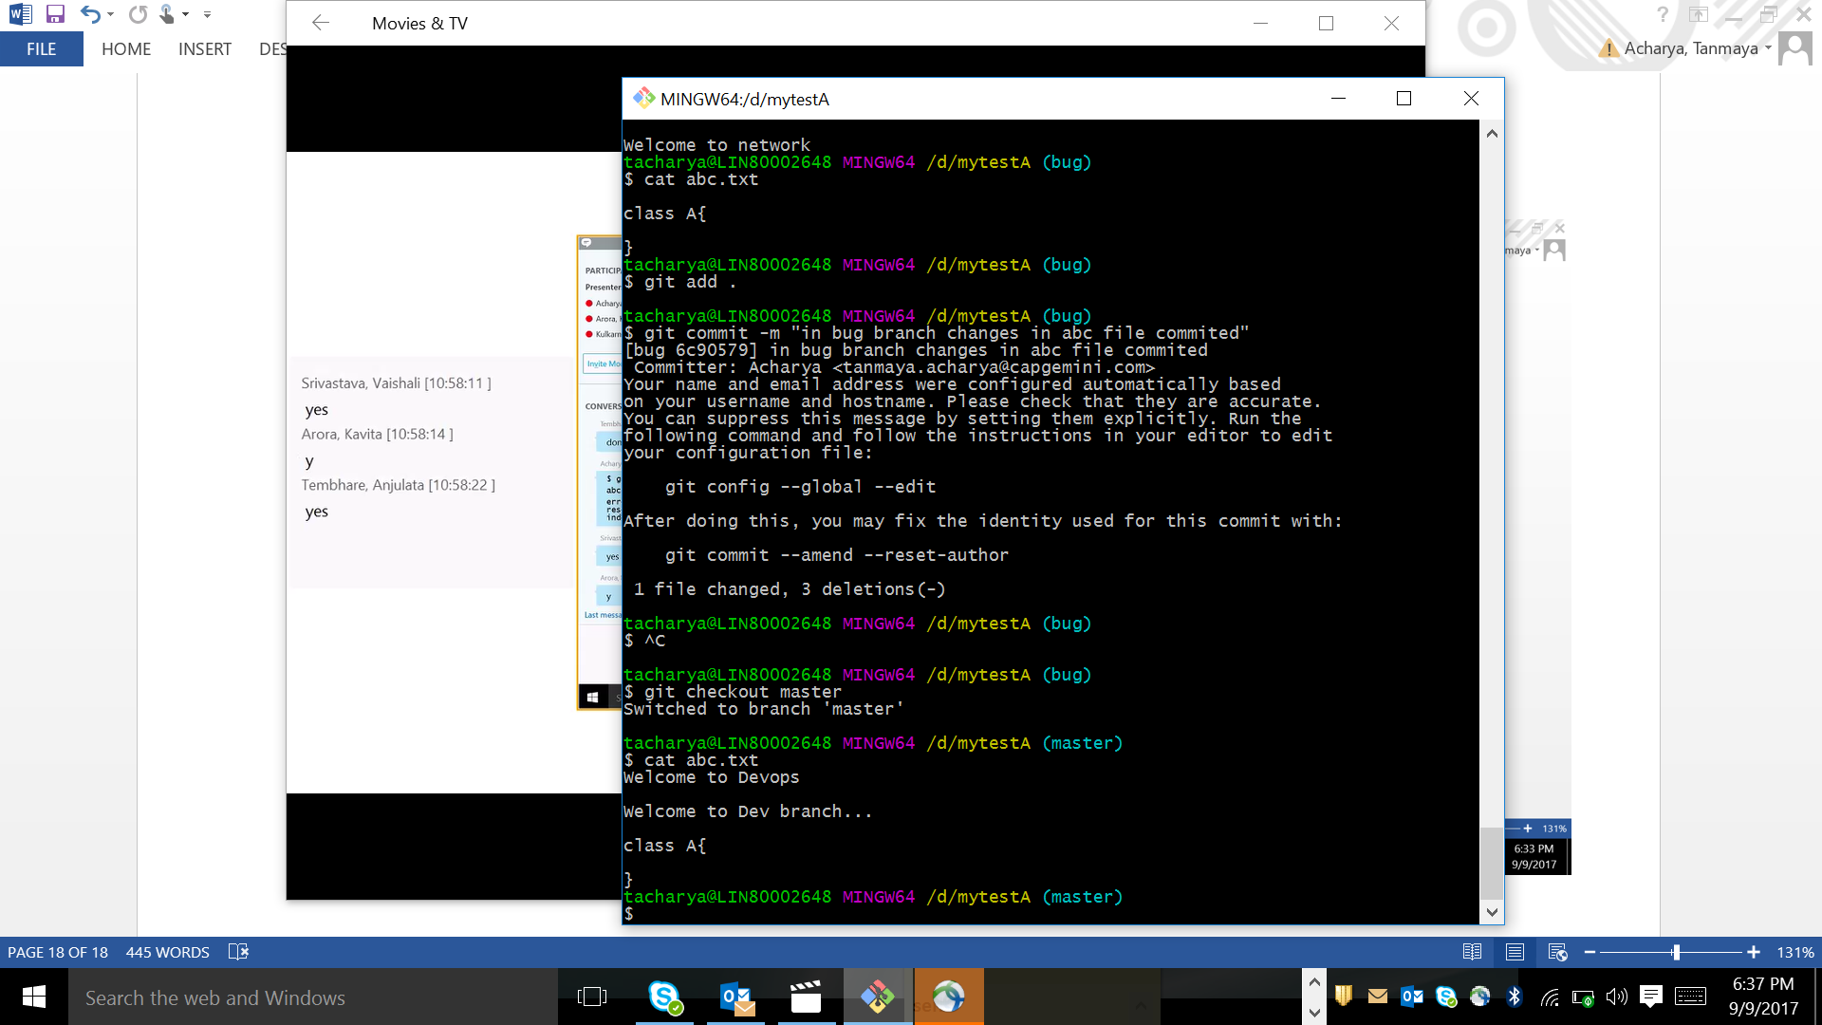

Now I have added a line in master – abc.txt file

“welcome to capgemini”

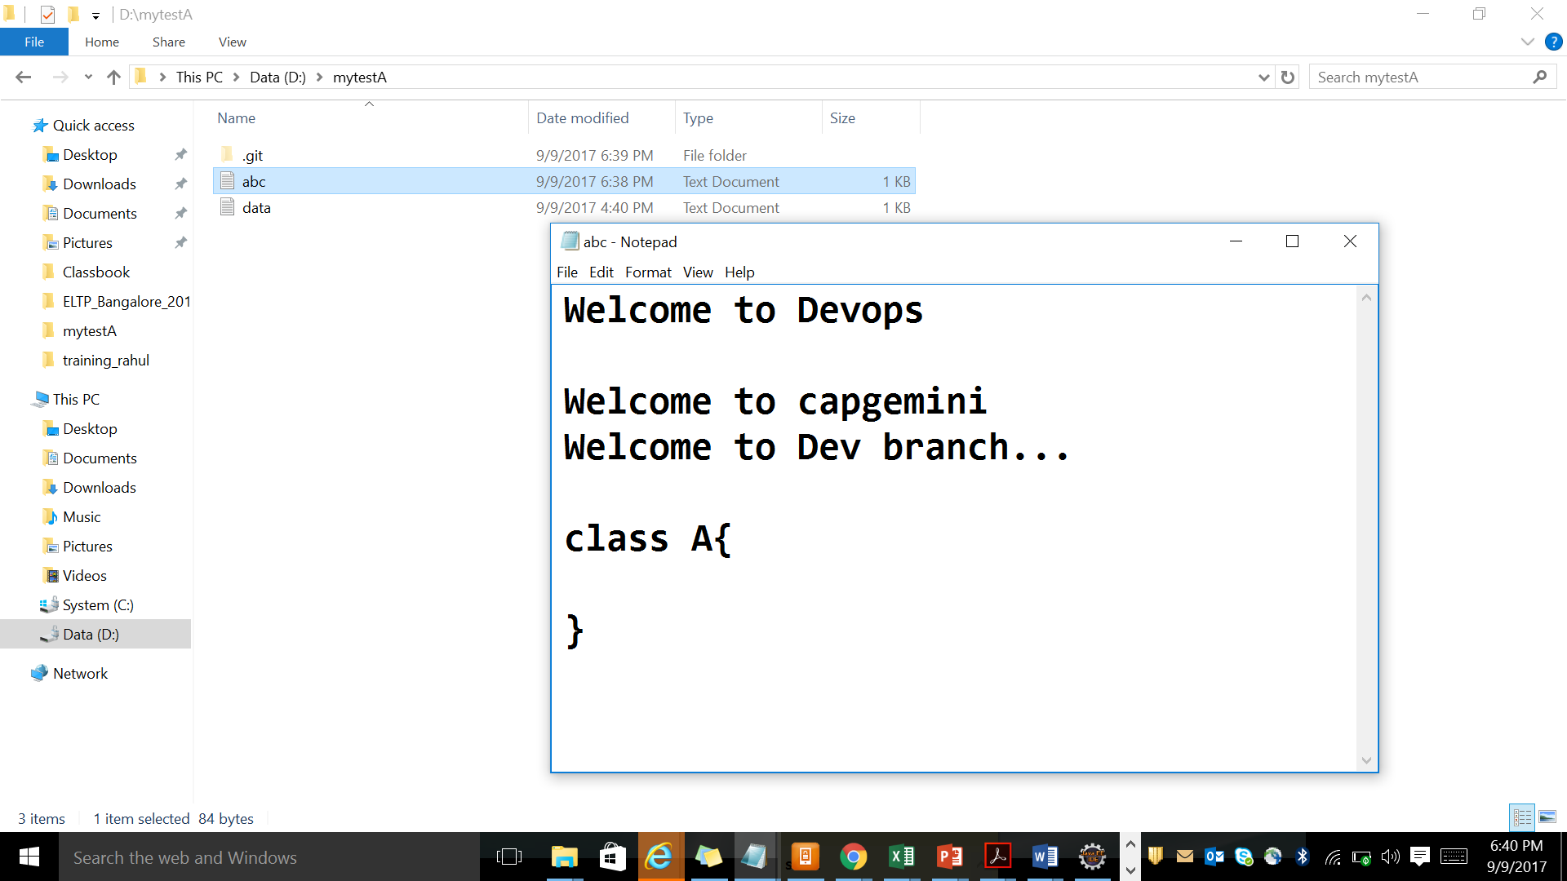

Then I add , commit

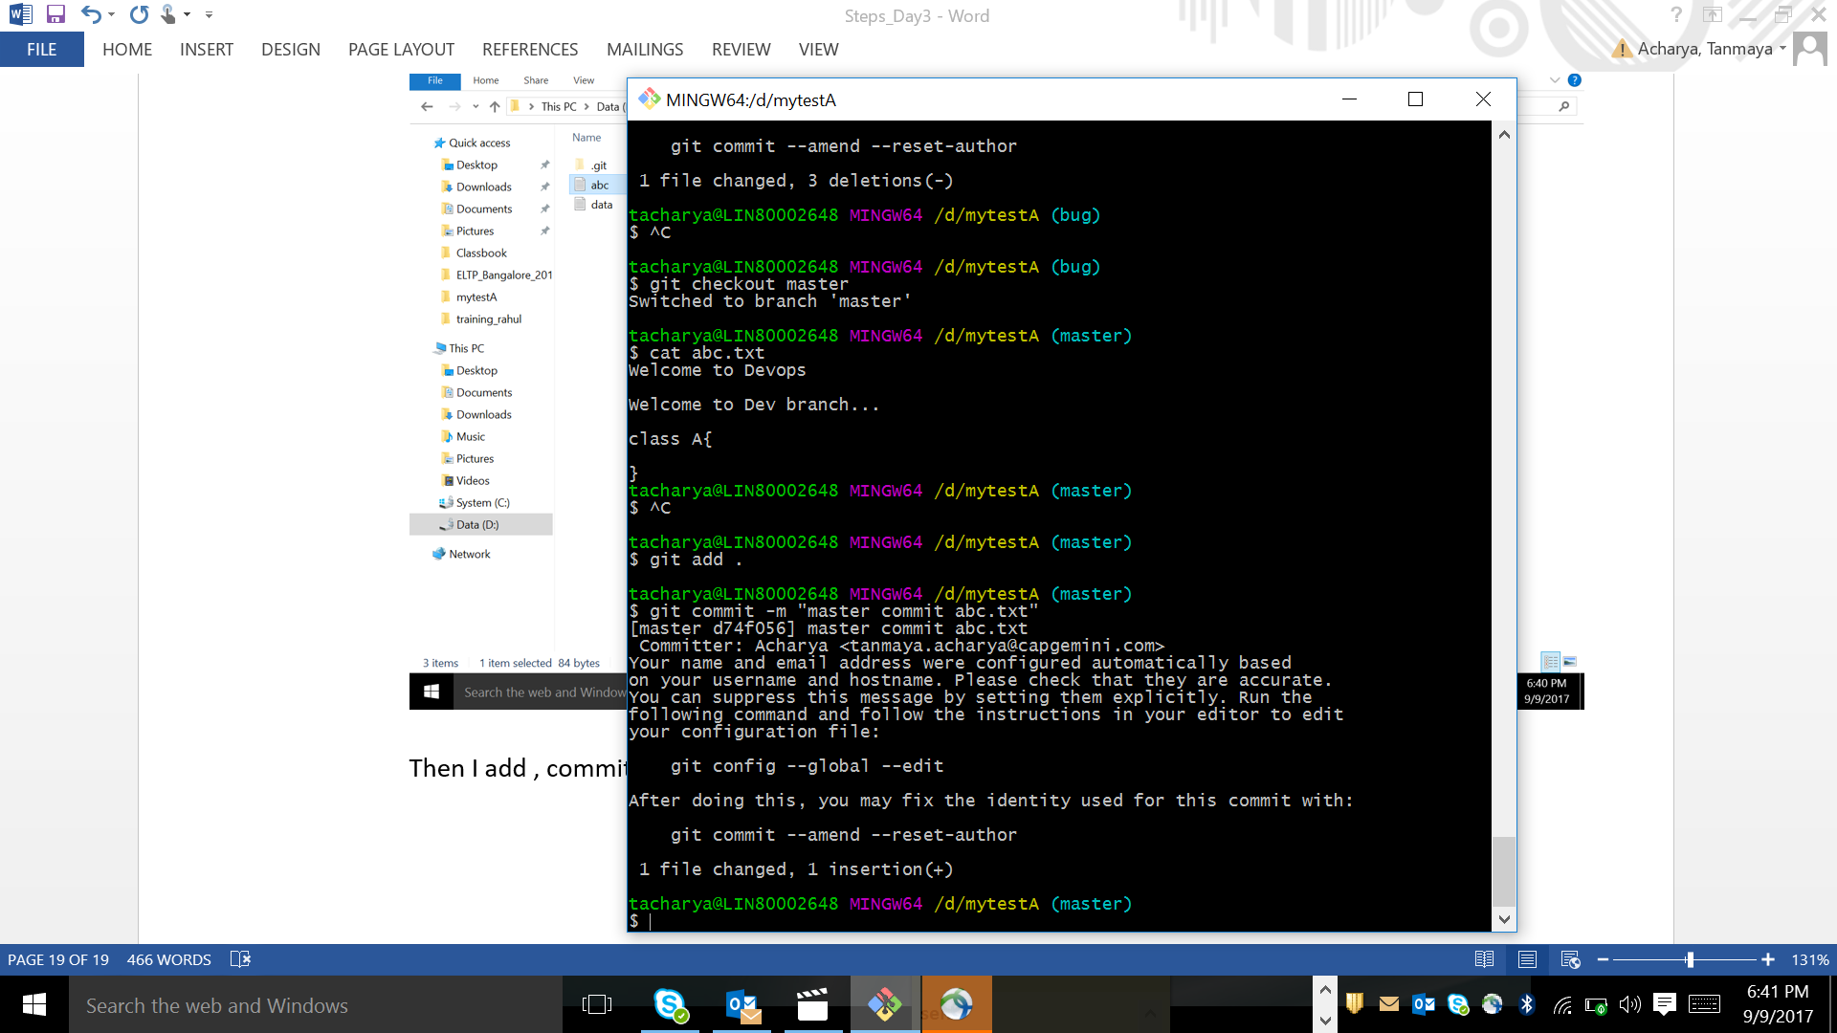

After merge to bug , error will get

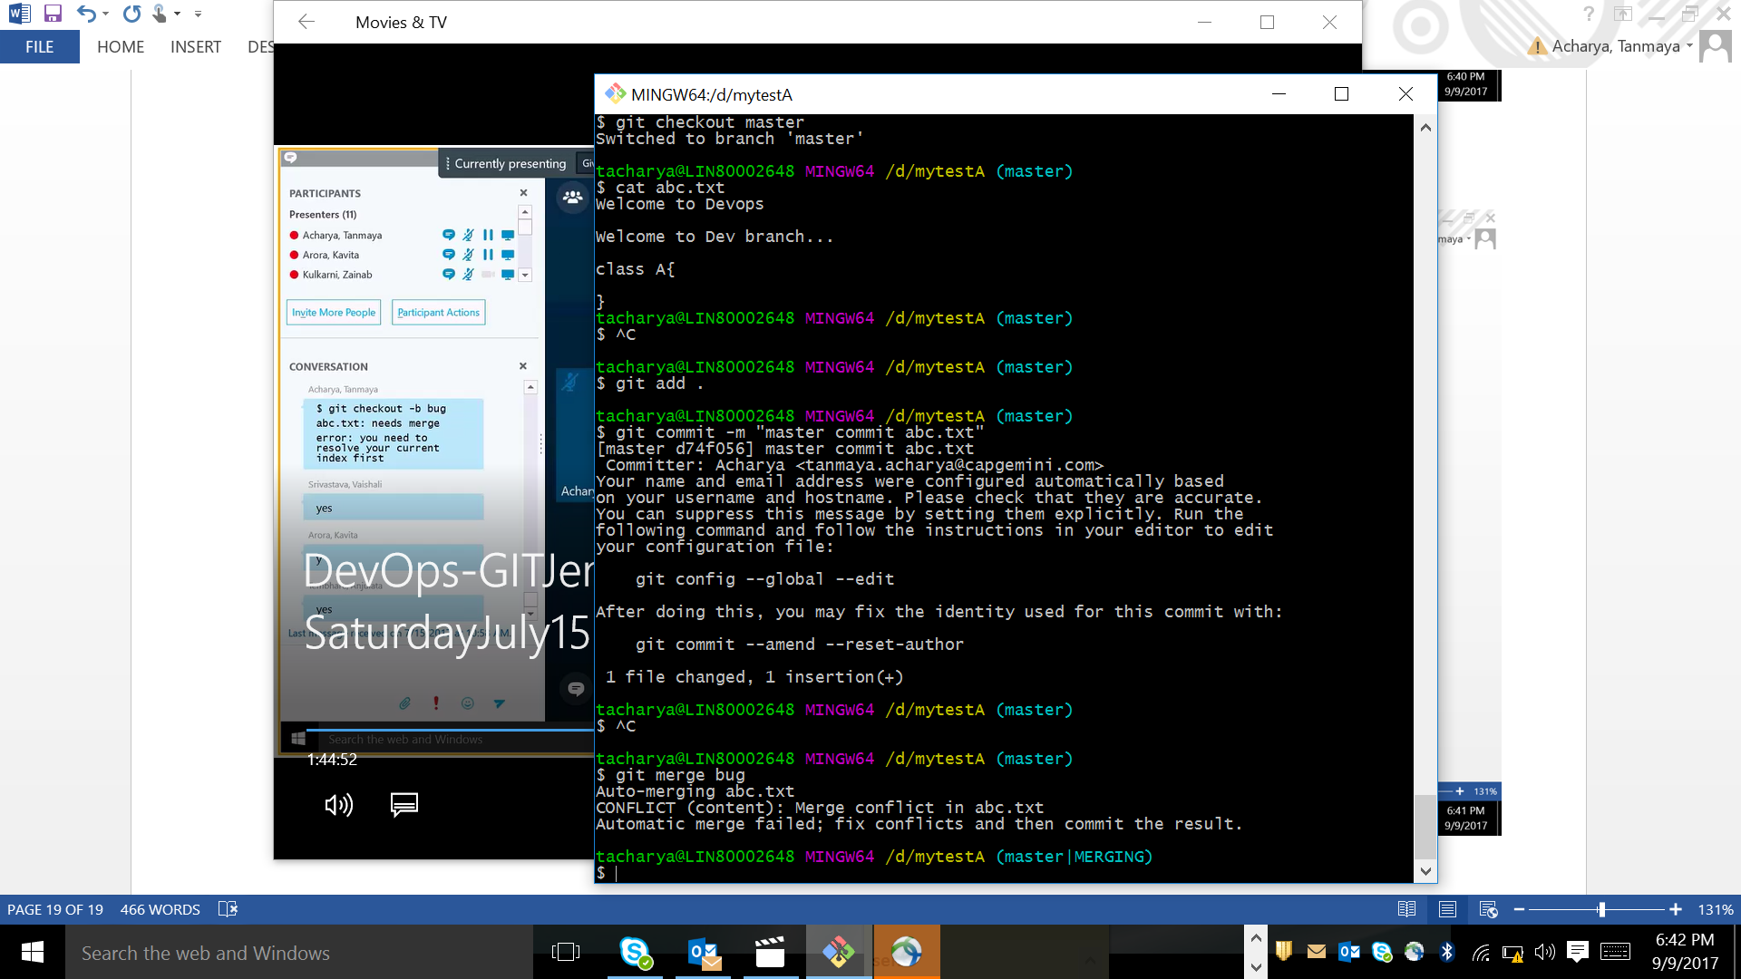

Problem is those head bug lines was no more in bug branch which was not merged to master before and master added 1 line after that

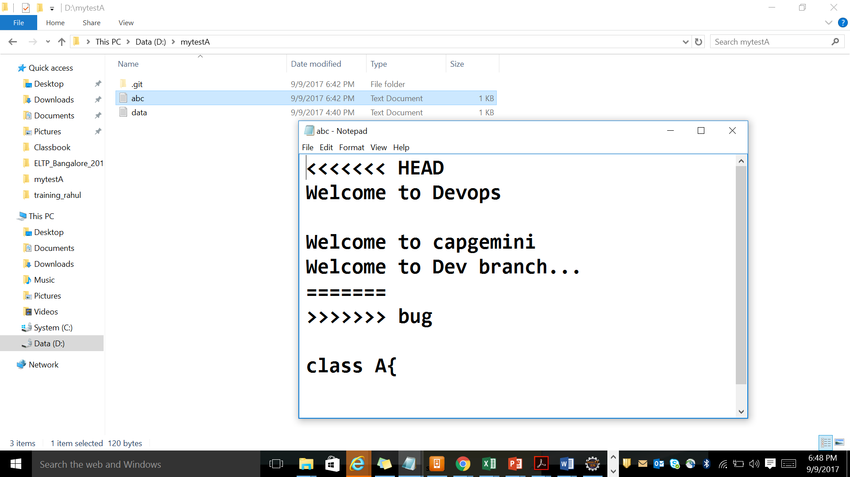

Delete the below content from abc.txt

<<<<<<< HEAD

Welcome to Devops

Welcome to capgemini

Welcome to Dev branch...

=======

>>>>>>> bug

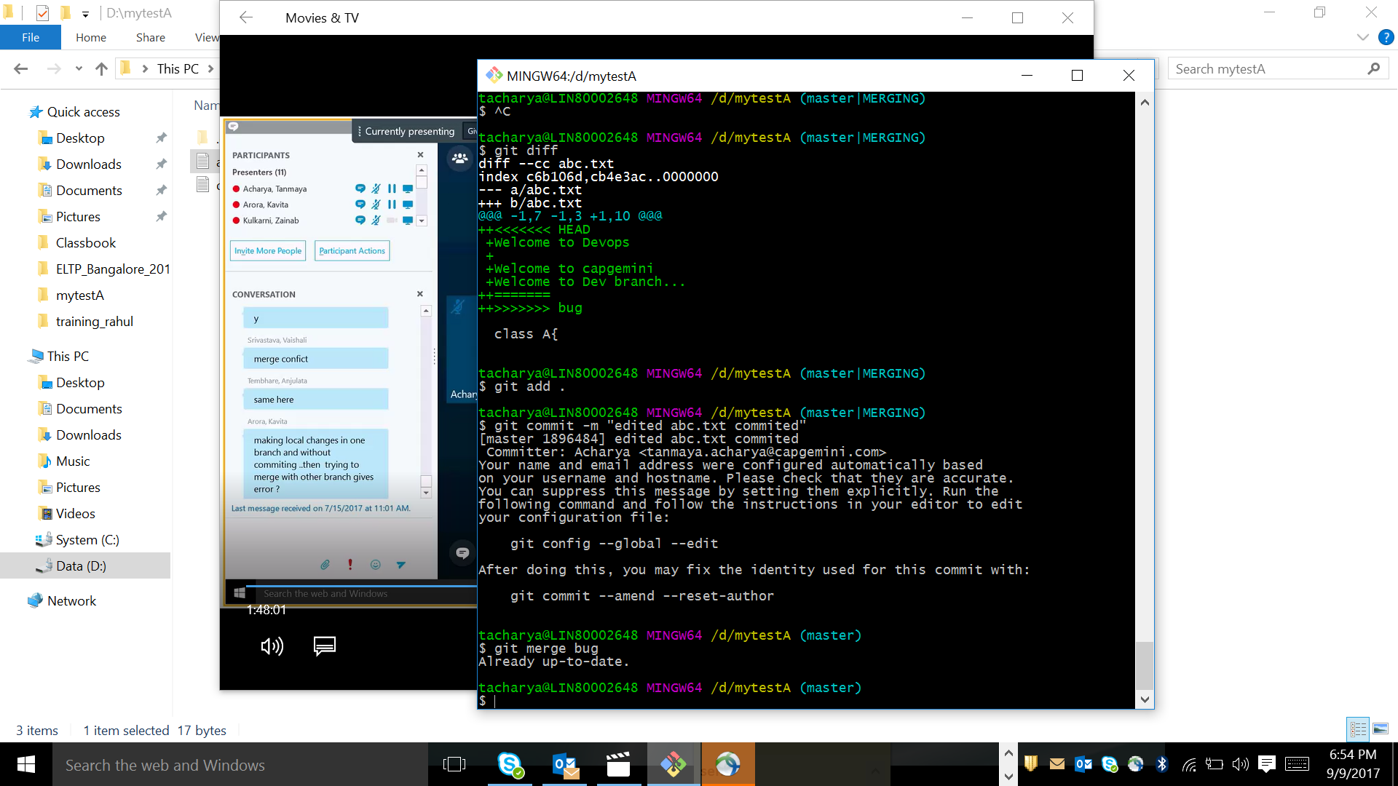

Remote repository

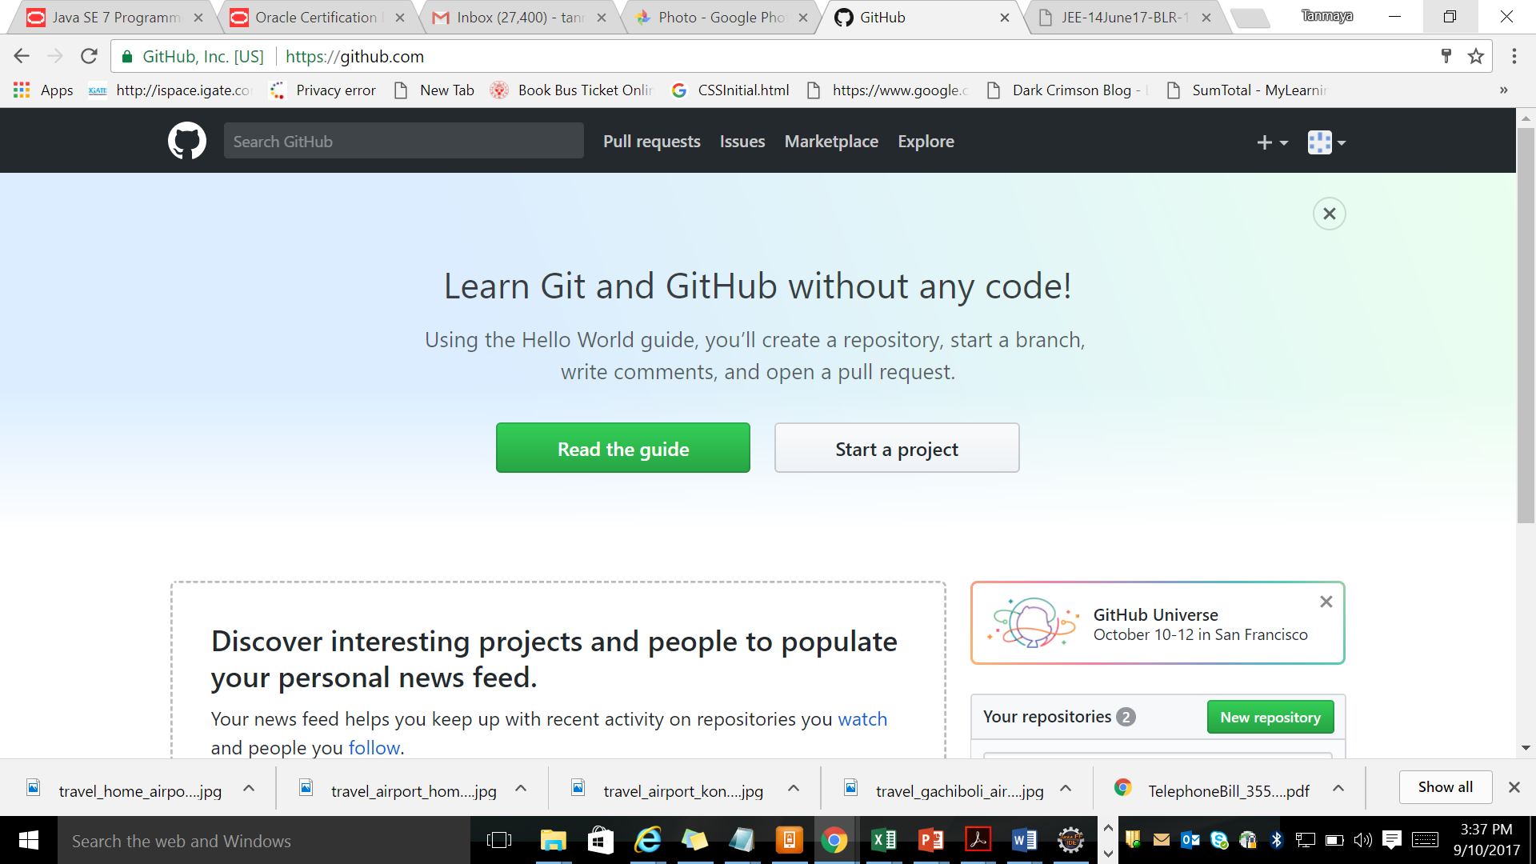

Click on new repository to create a new repository. Then give a name i.e firstdemo1 . make it public only , as private needs amt , then click on create repository.

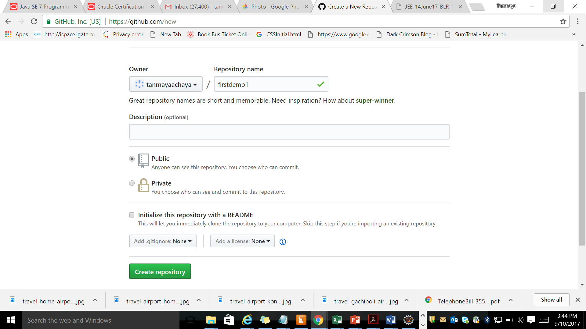

Staging Area

Working space

Working station ---- add ----🡪 Staging area ----- commit------🡪 LR ----- push-----🡪 RR

RR

LR

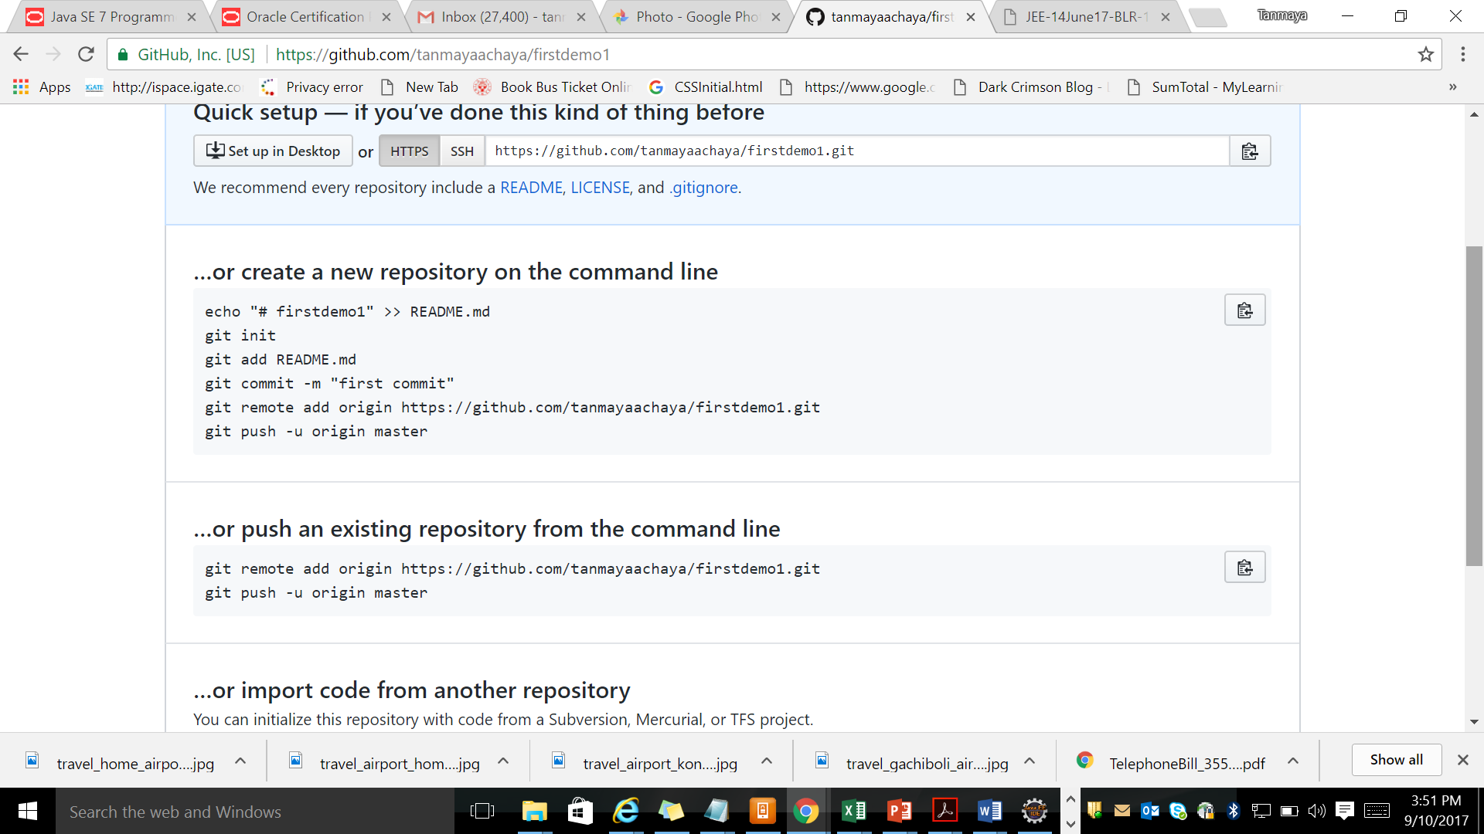

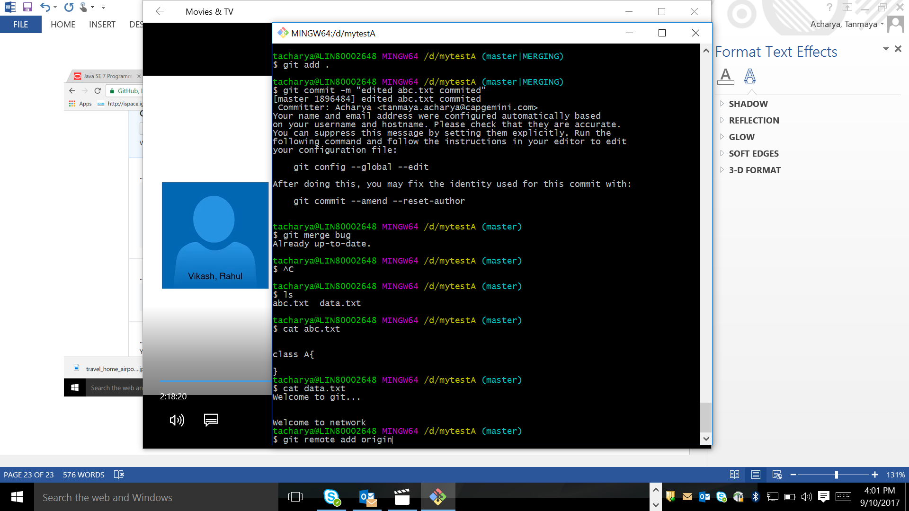

I need to copy the remote repository url from git hub site and paste in above coomand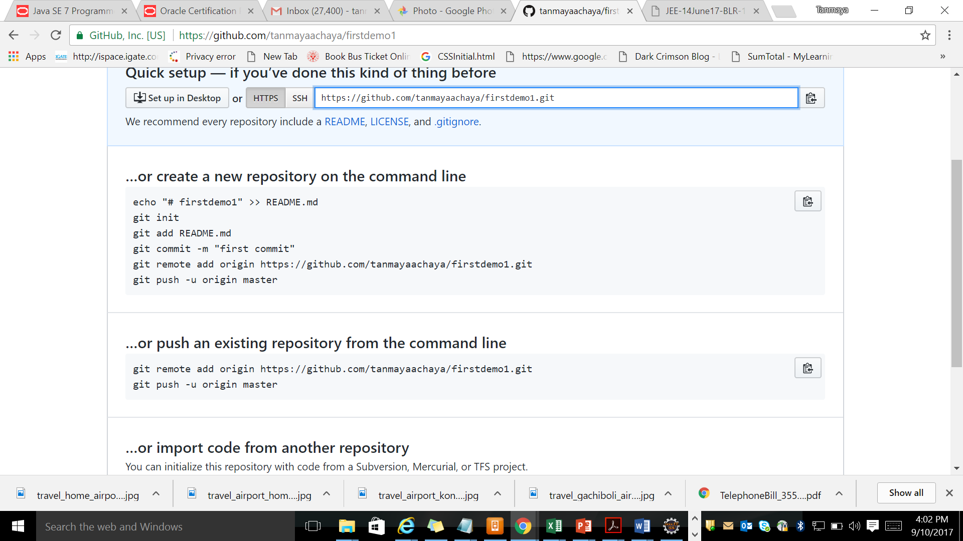

RR name is origin

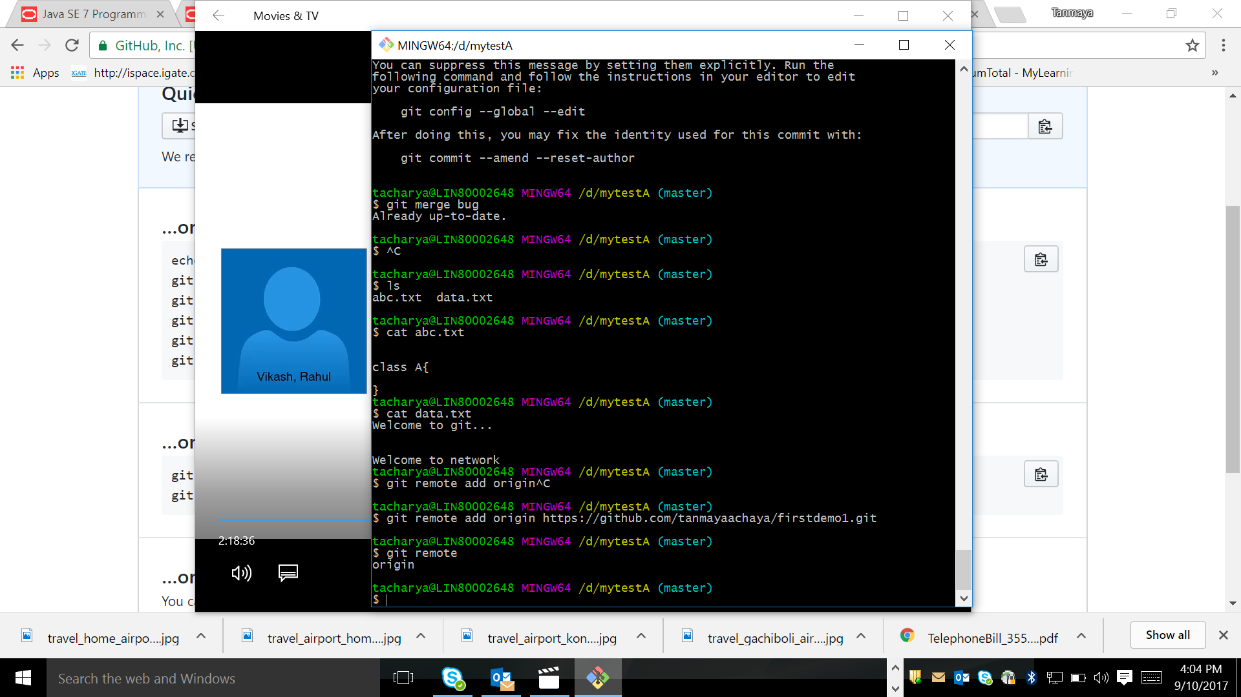

Git remote command is used to see remote repository name

Now we need to push the LR to RR . pfb the command

-u is used to track the commn between LR to RR

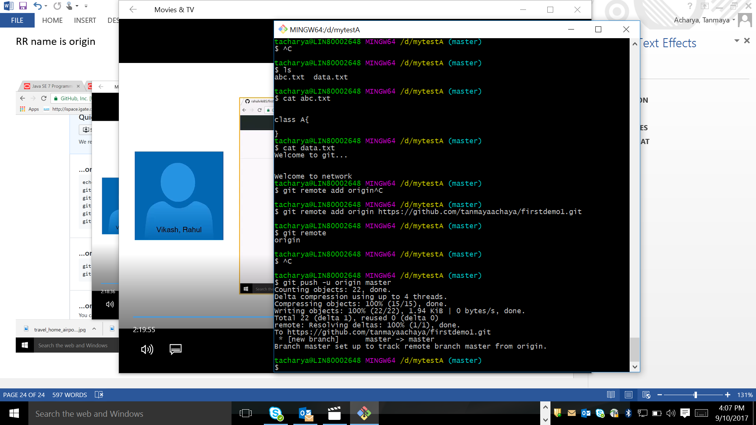

After this you can see your repository

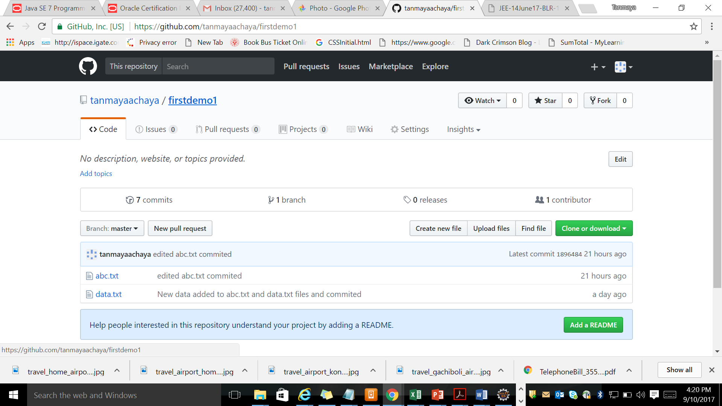

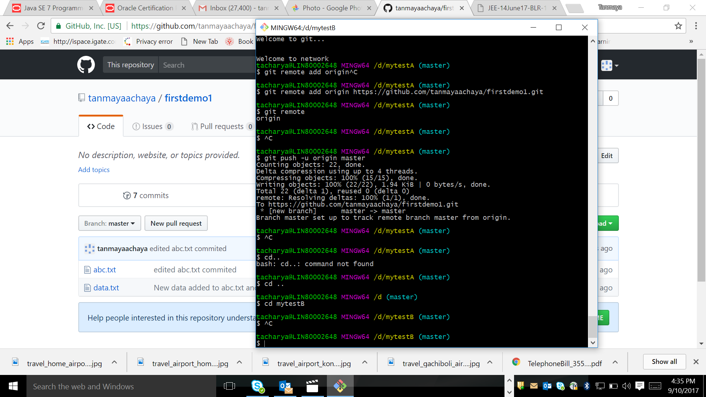

I have another repository mytestB . I want to pull the data from RR to mytestB . please see the below command

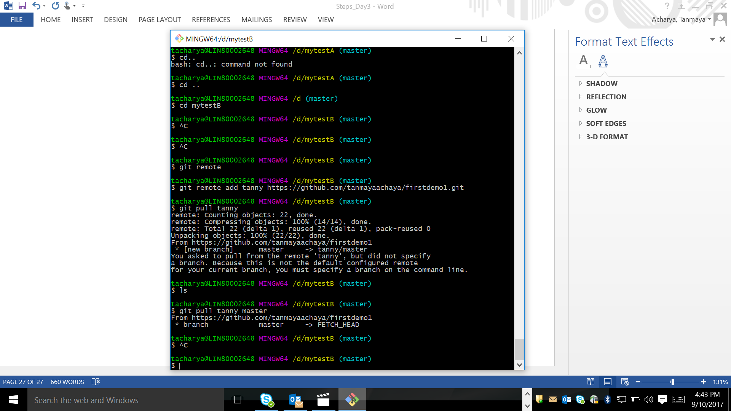

Creating another repository mytestC and copy the content by using fetch command

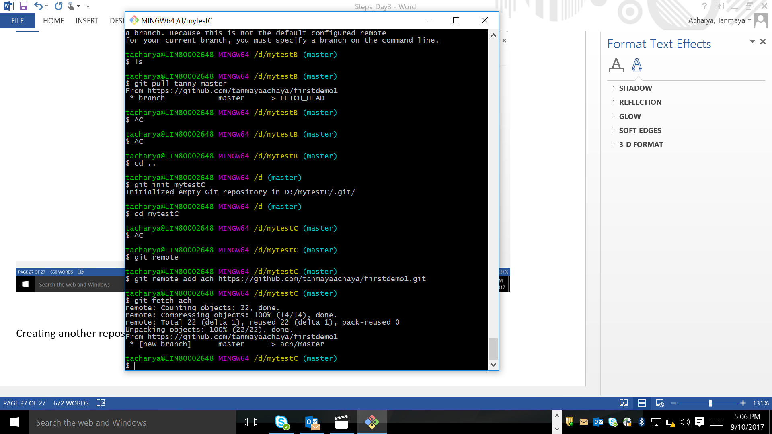

After using fetch command in mytestC folder data will not shown bcz fetch command get the data from RR to LR .

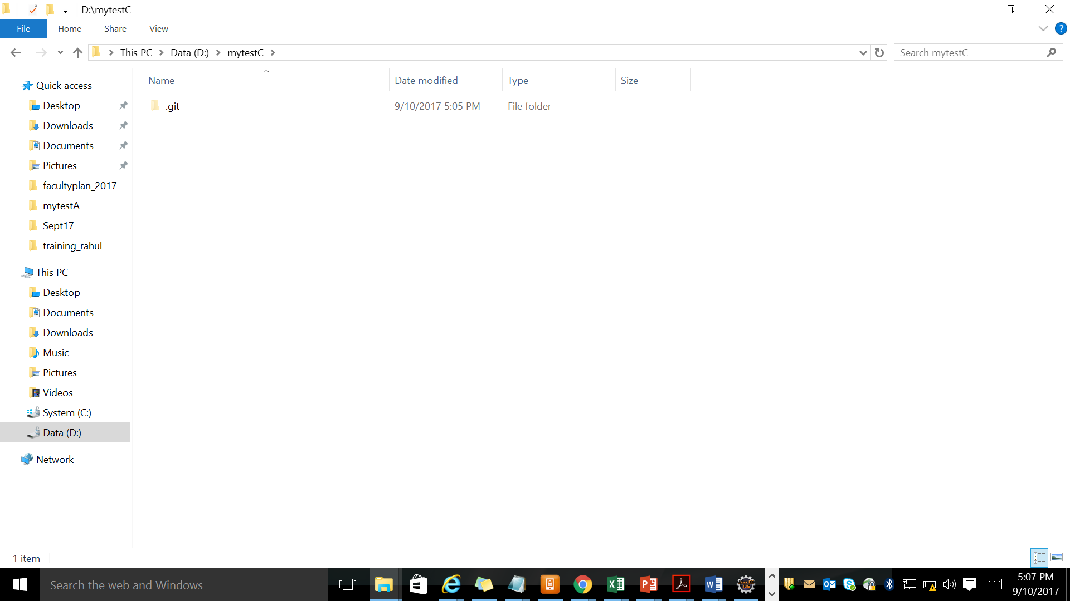

To get the data to shown to Working copy type below command

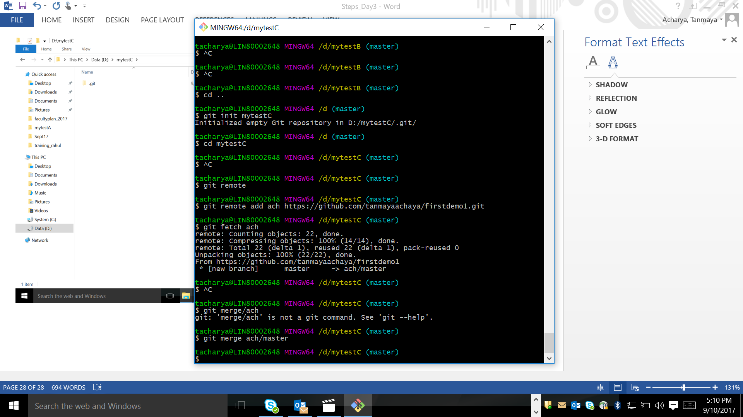

Pull - is used to get the data from RR to WC(Working Copy) directly.

Fetch - is used to get the data from RR to LR and

Merge - is used to get the data from LR to WC(Working Copy)

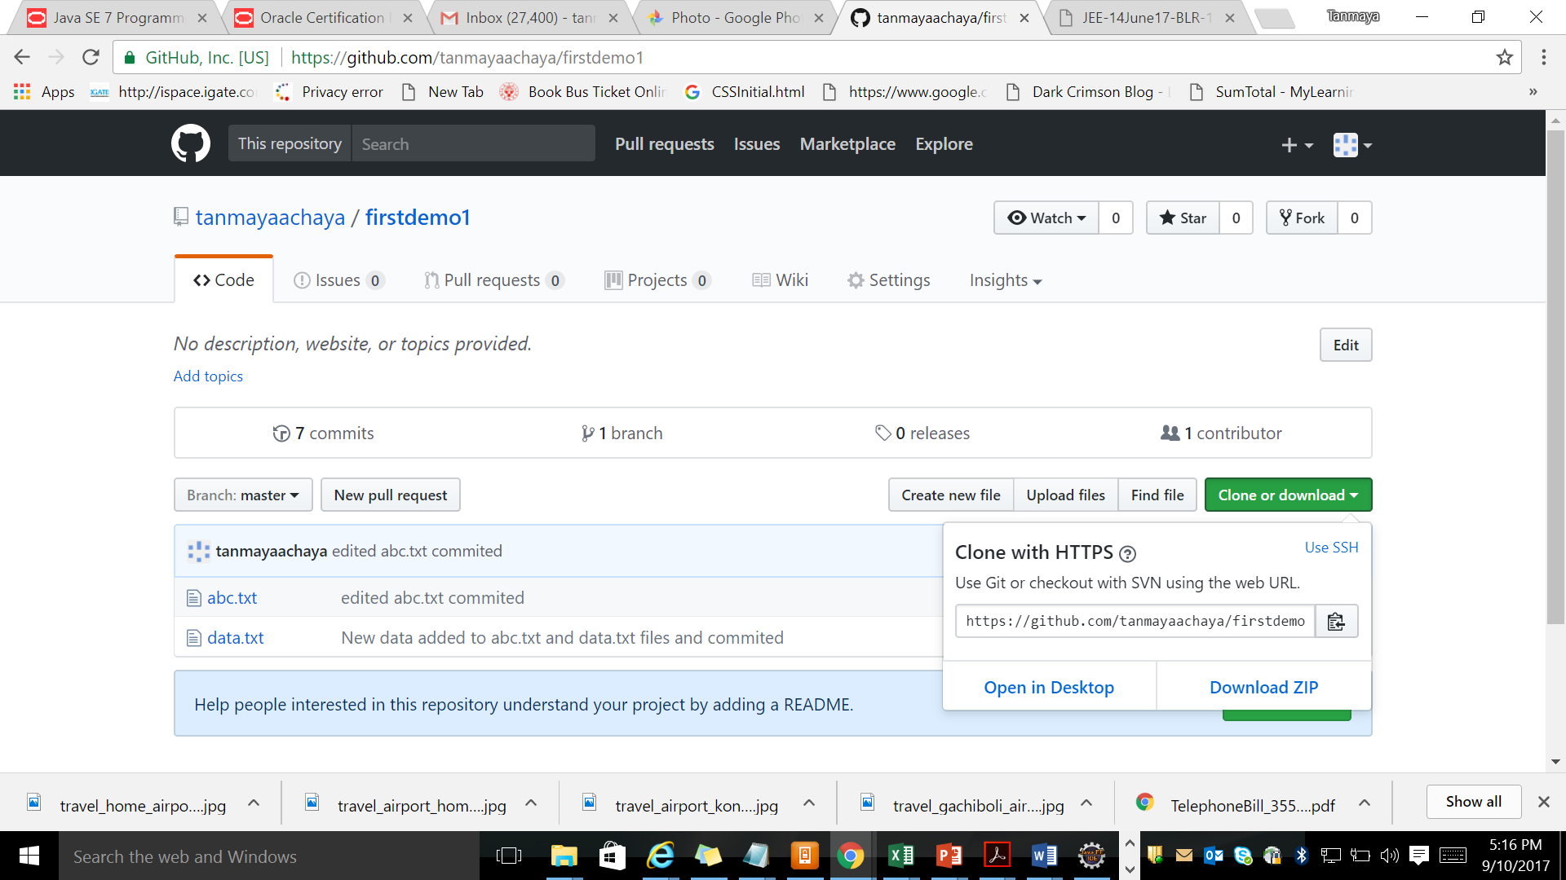

I have created one more folder testD in d:\ . it is not repository . .git folder is not there.

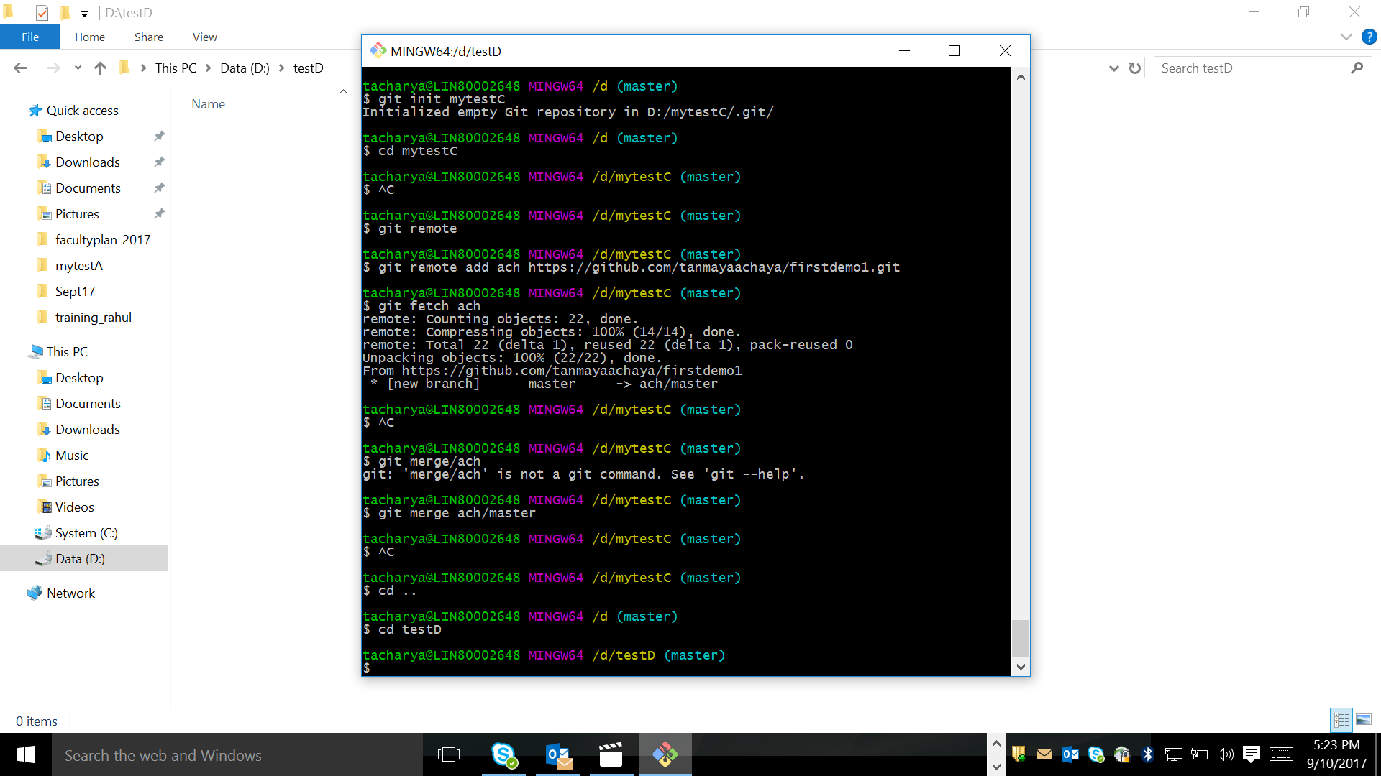

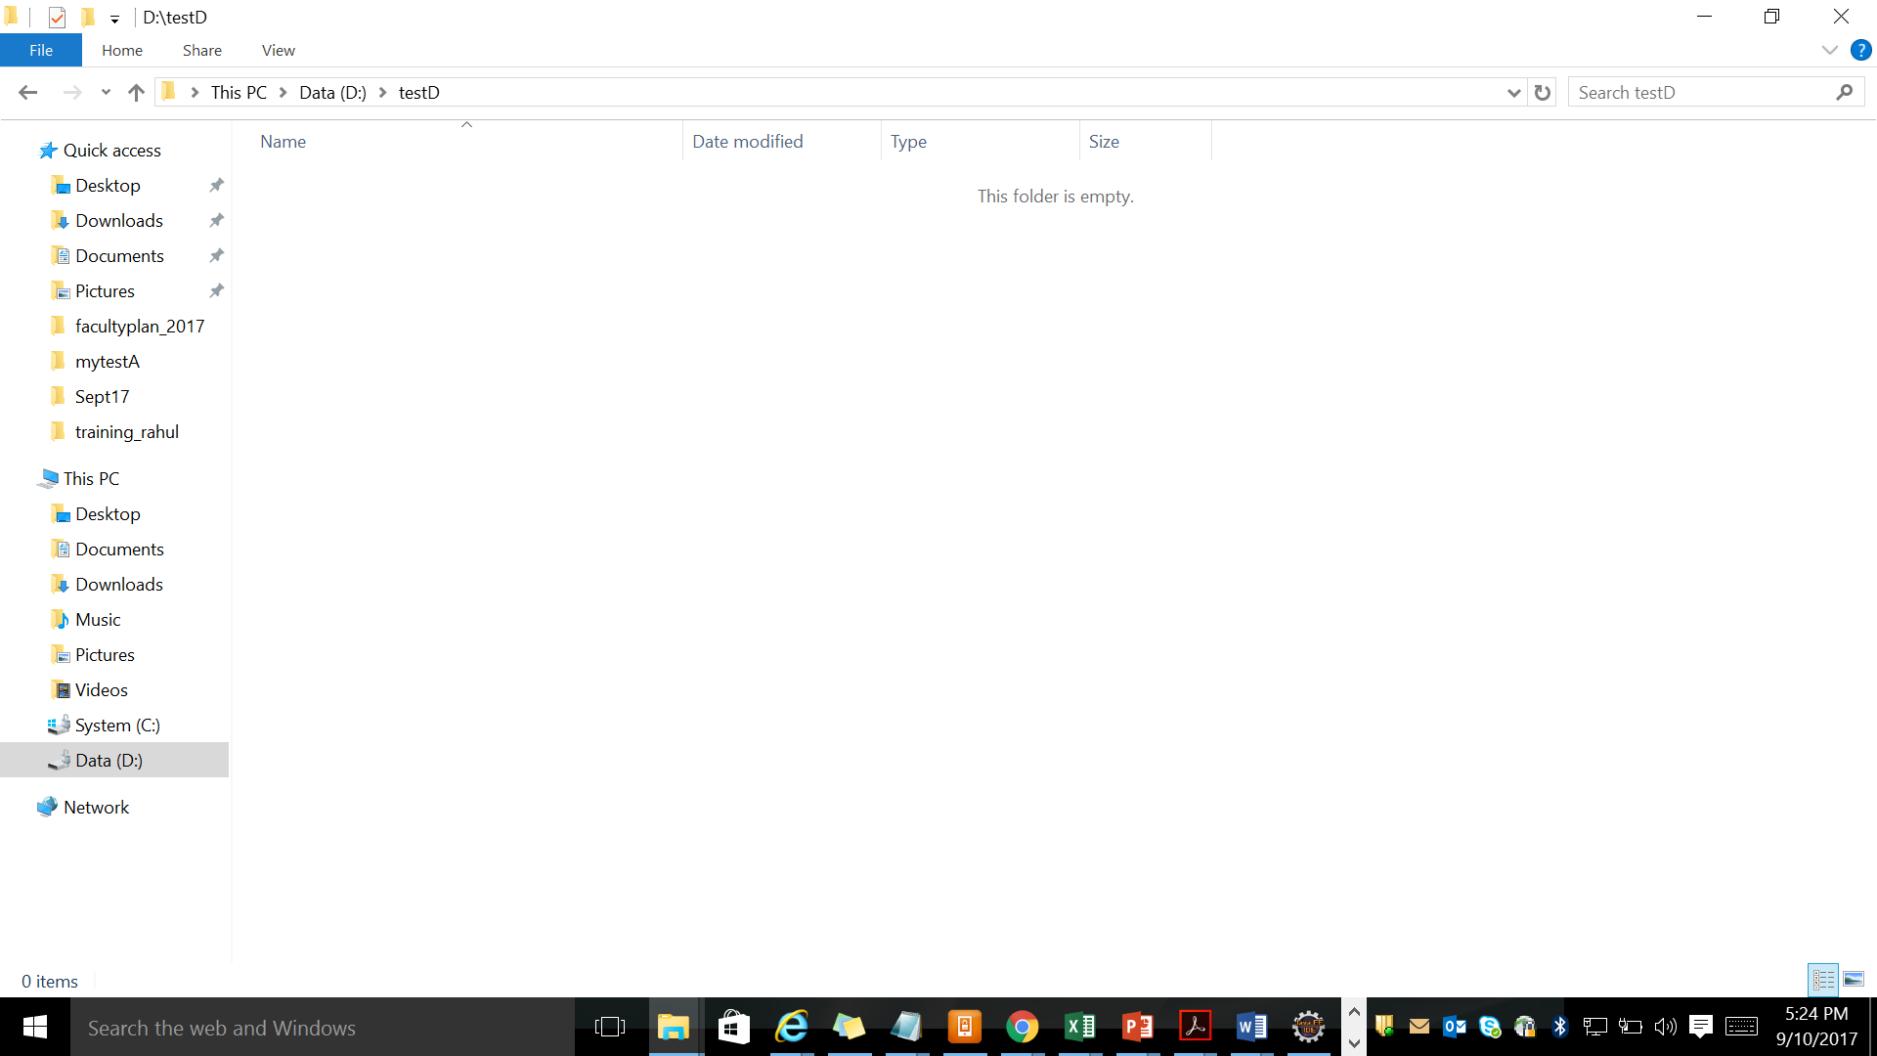

Now I am cloning my repository to testD location

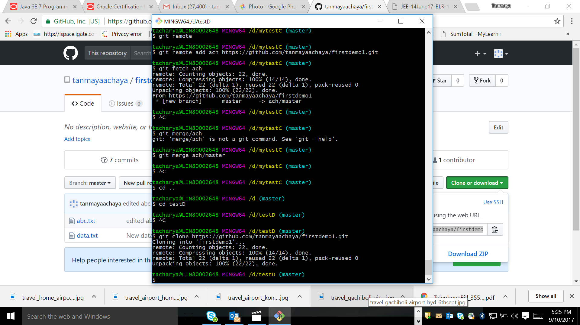

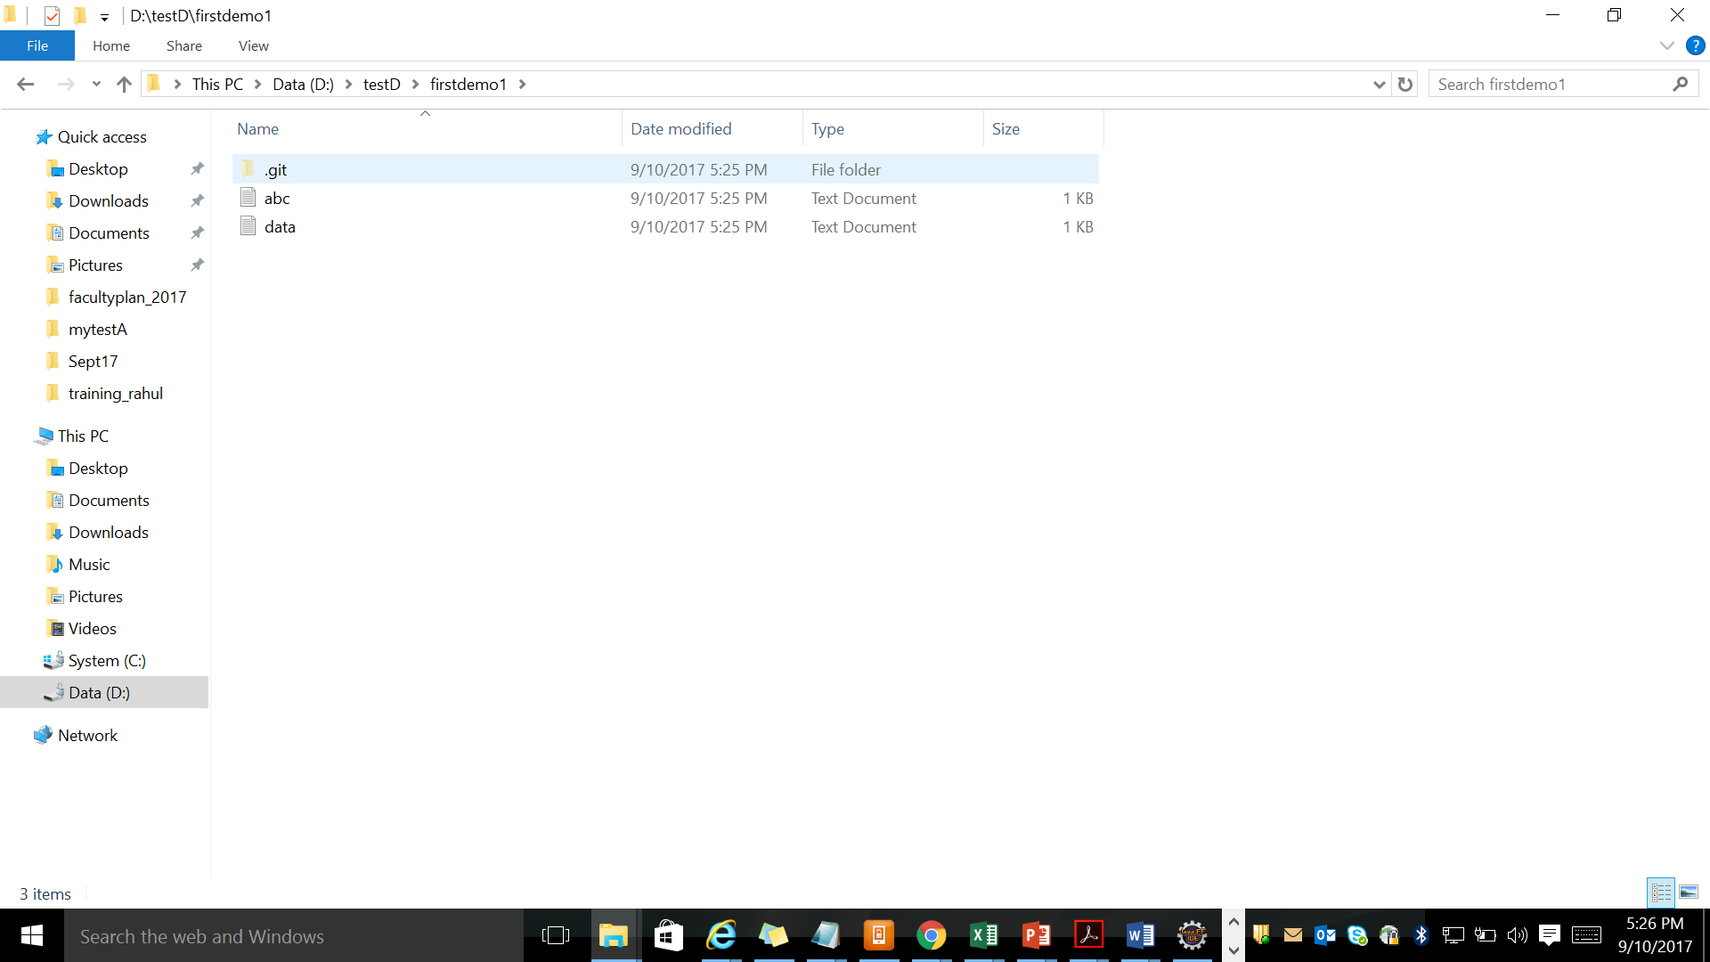

Clone create a copy of remote repository in our system. Developer first get the clonew copy to there system and start working on it.

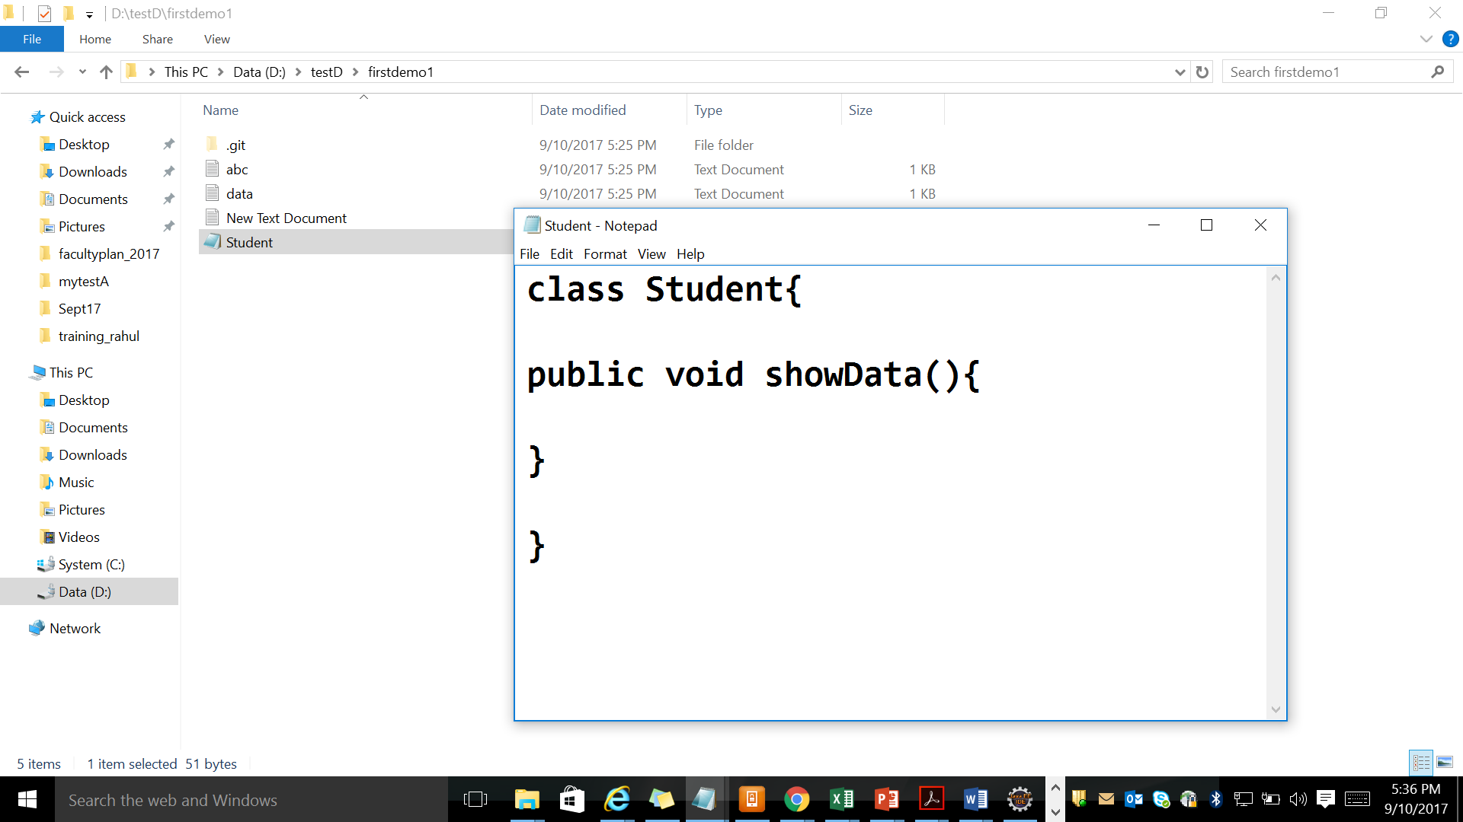

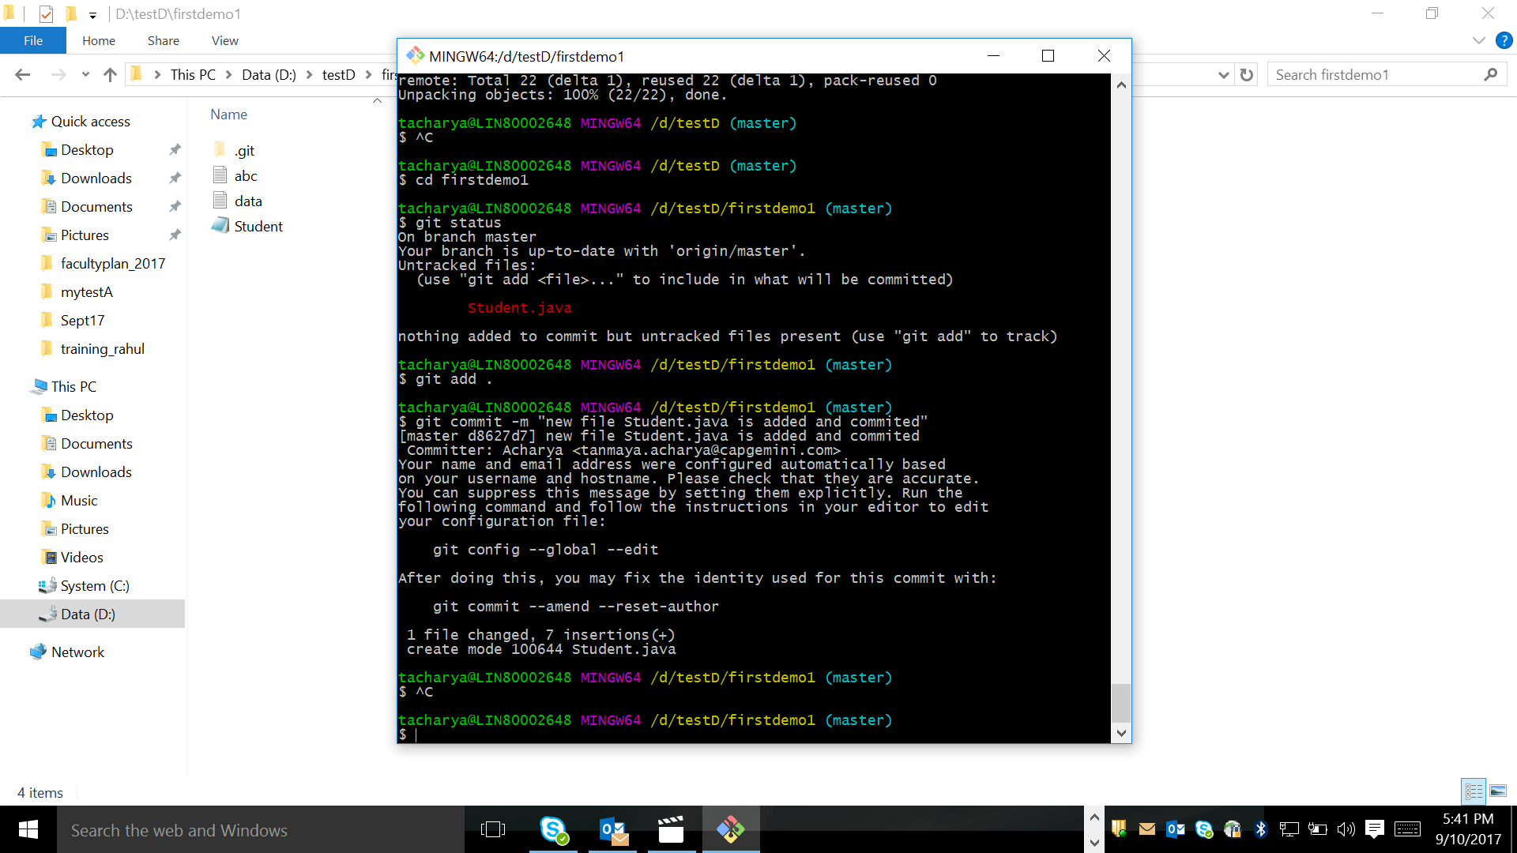

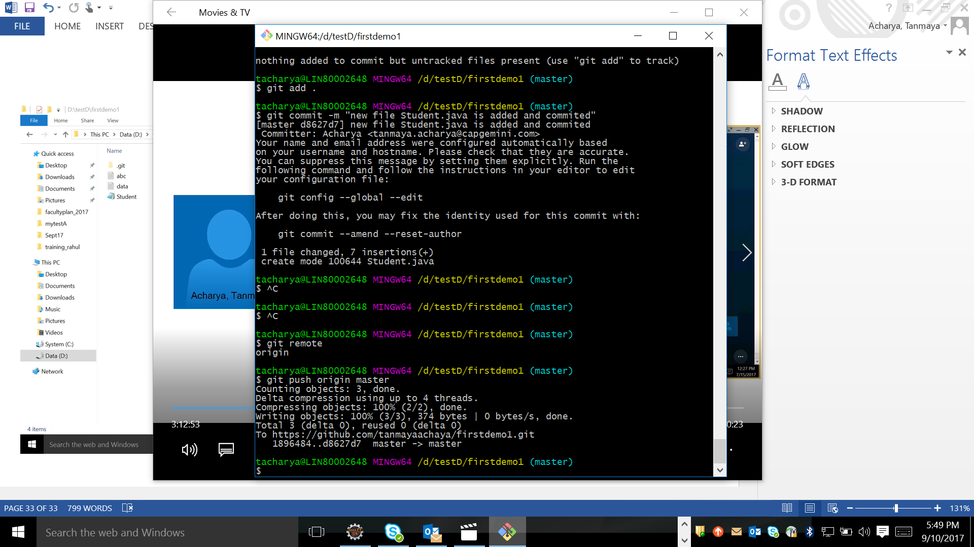

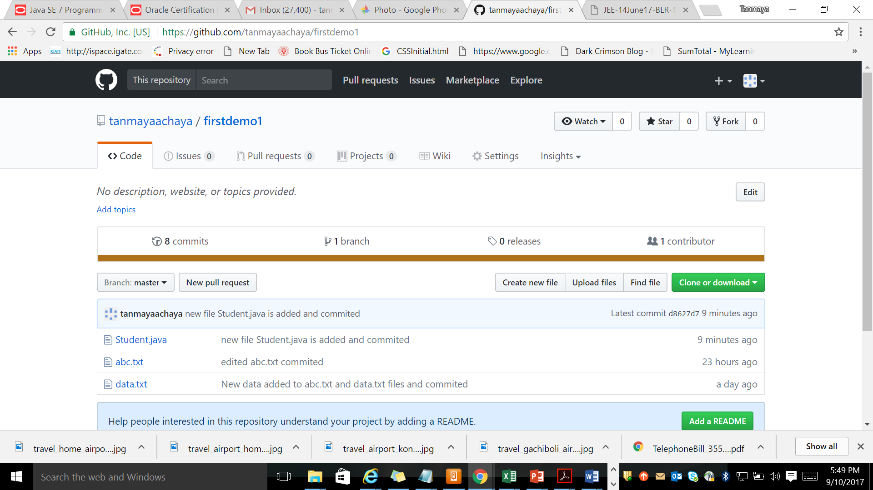

I am creating a remote repository in local system by using –bare command.

I created a folder in d:\mygithub

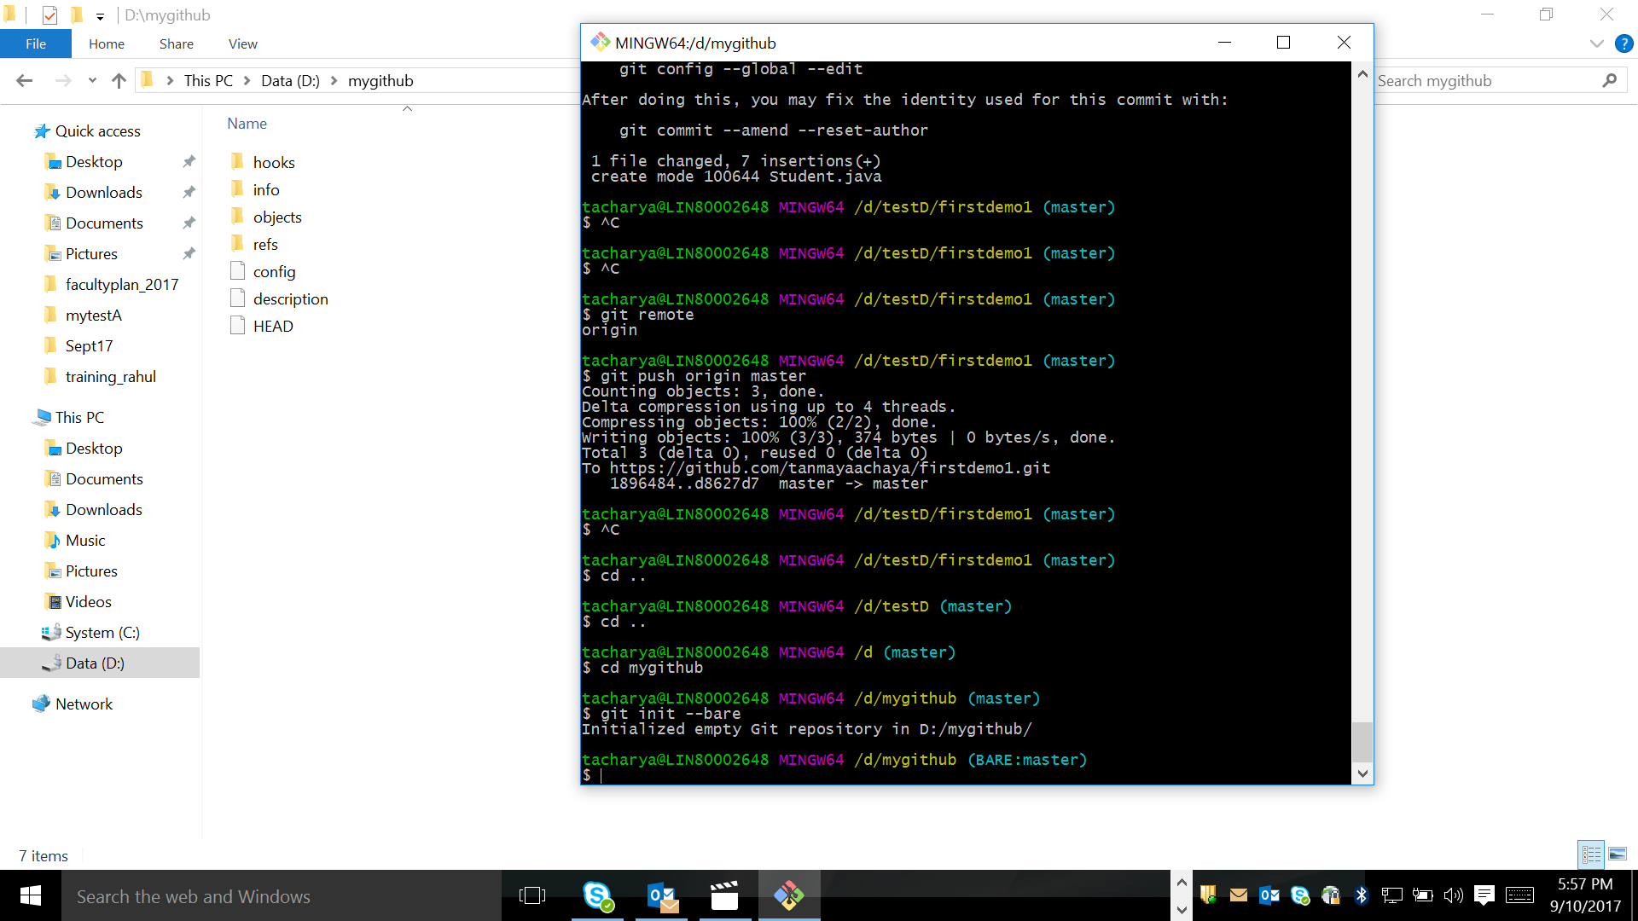

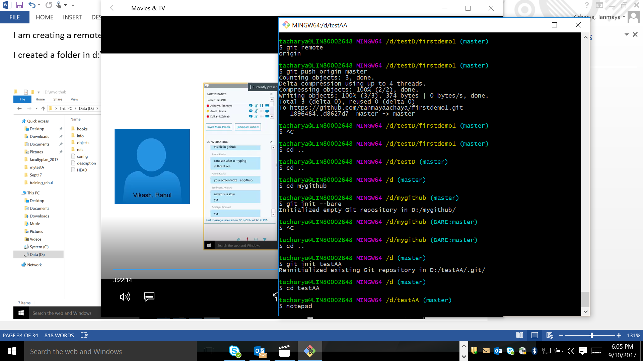

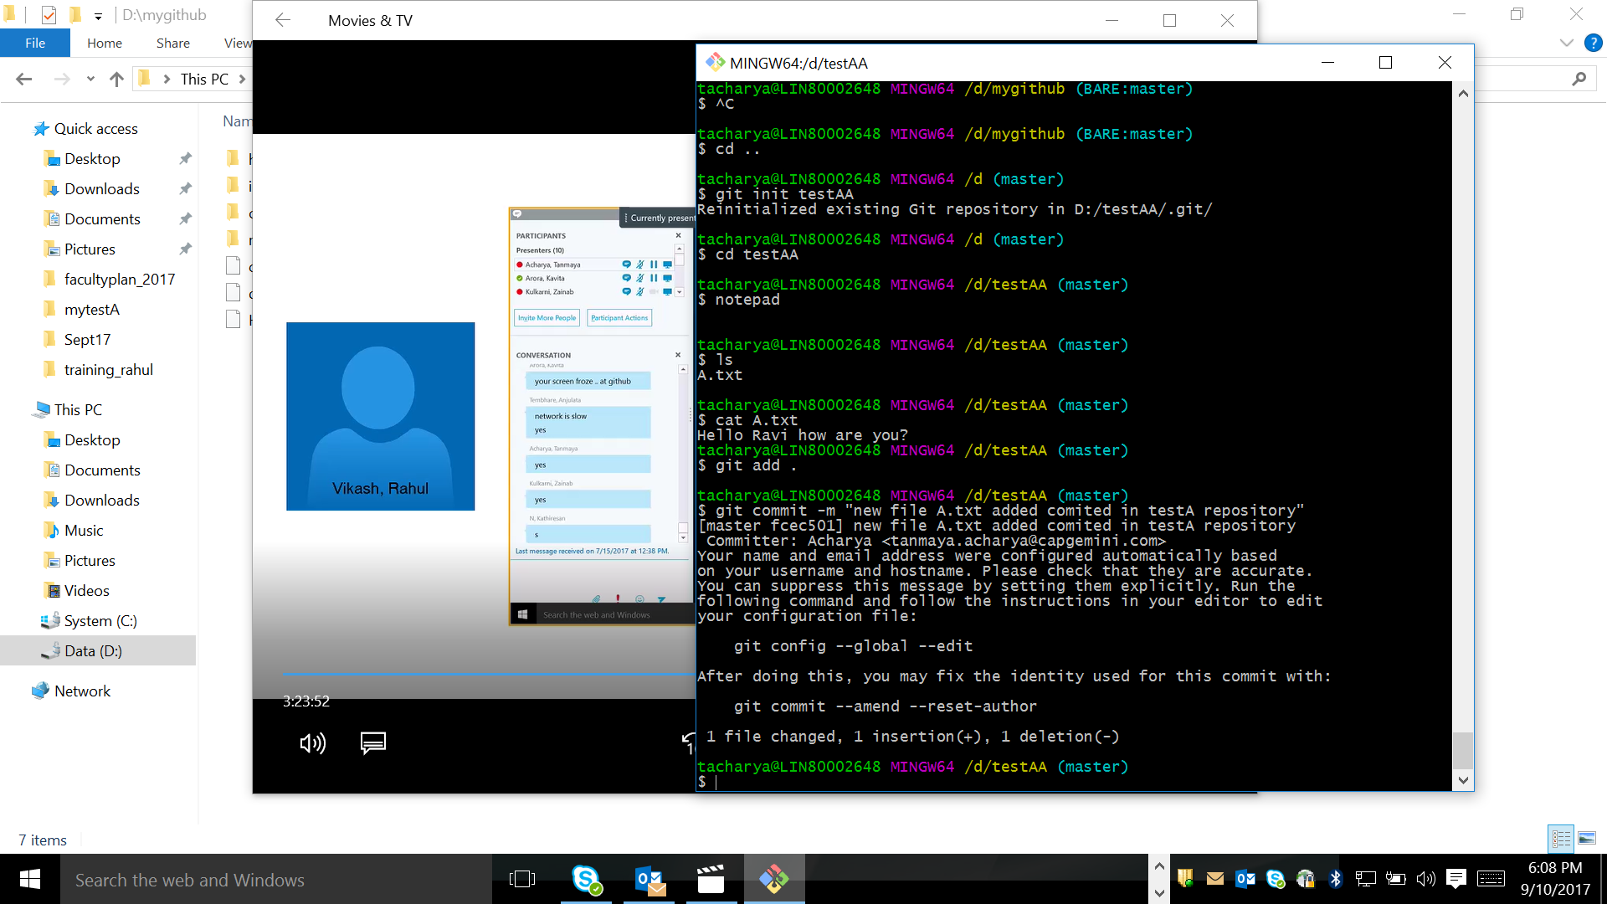

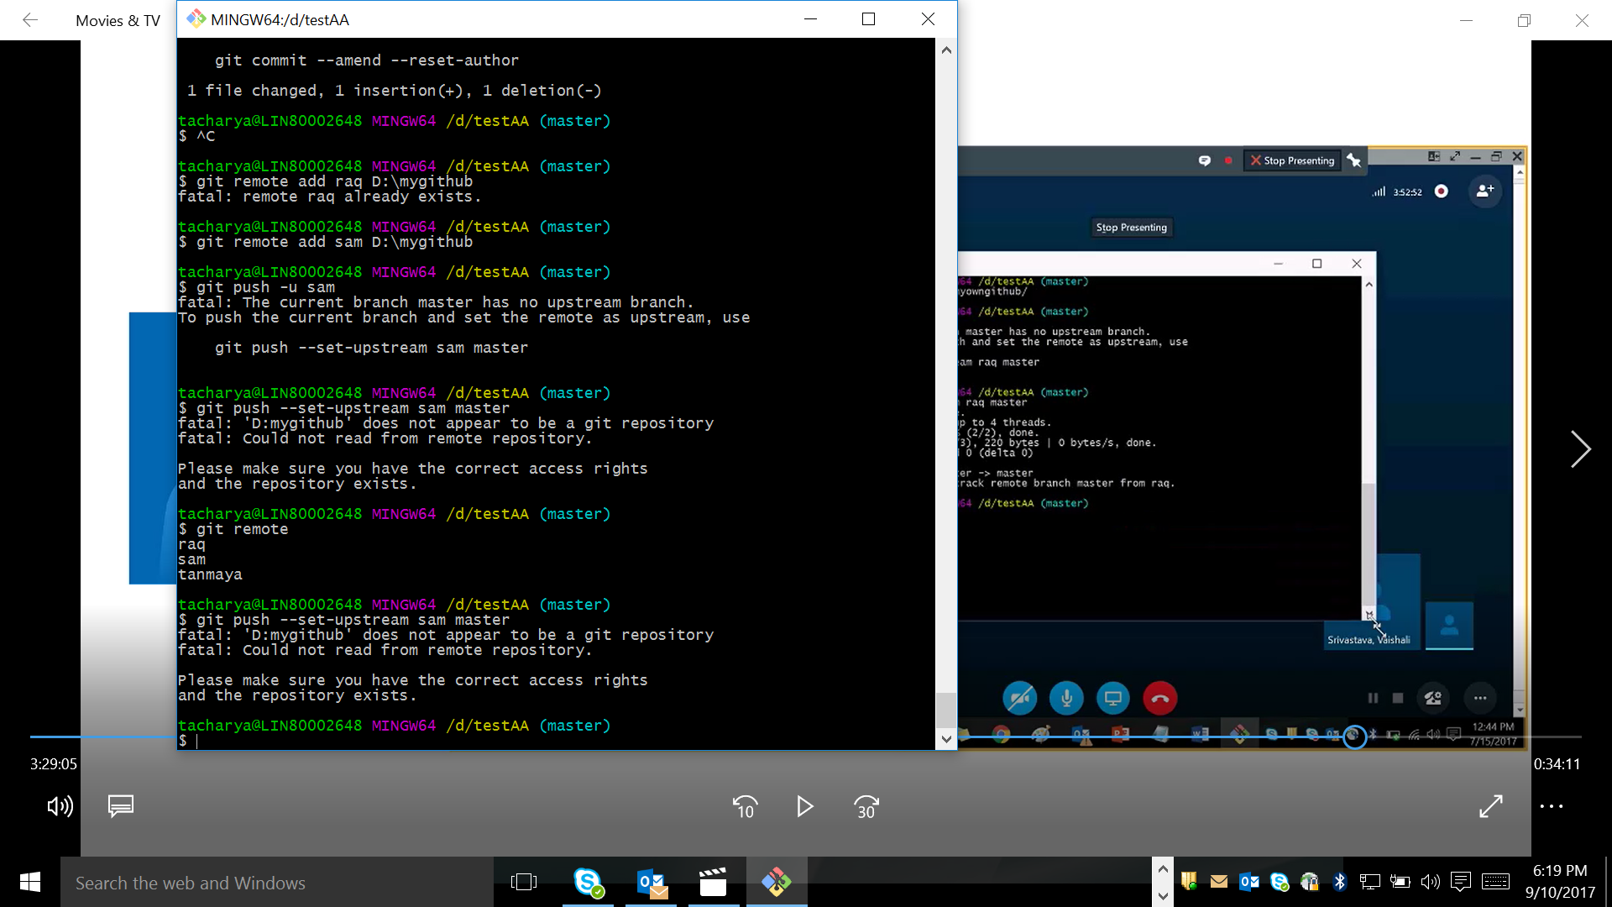

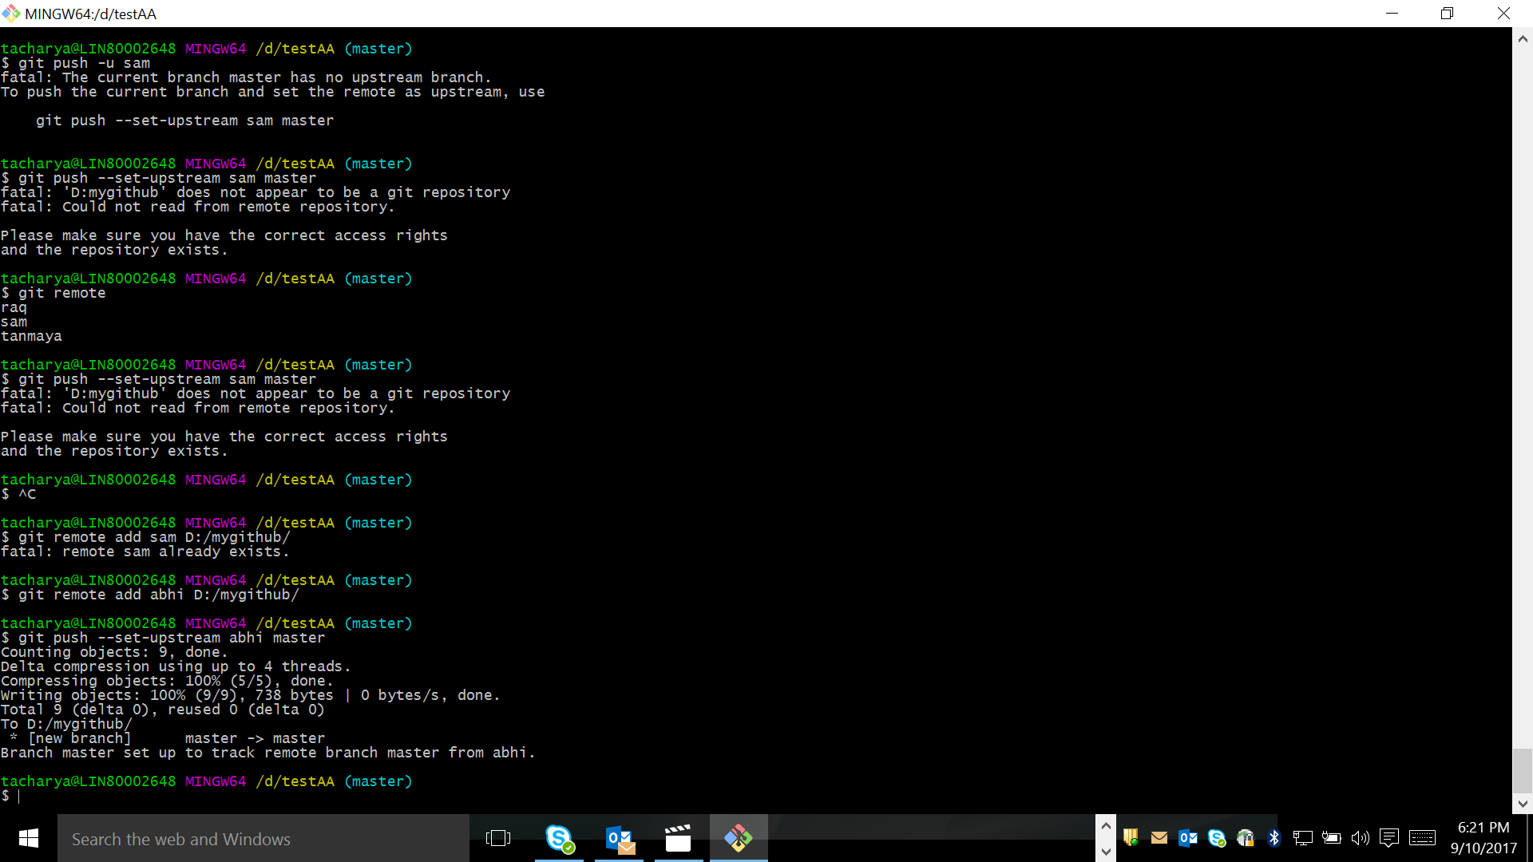

How to pull the data from local system remote repository toi a new repository testAB

